**Project Title: Hotel Management System   
for Hotel Staff**

**Team members:**

**Navyaprabha Rajappa**

**Pradeep Kumar**

**Table of content**

1. Introduction
2. Motivation, goal/objectives and scope.
3. Related works
4. Application system functionalities
5. Conceptual database schema
6. Logical database schema
7. Physical database schema
8. Database technology
9. Description of the prototype system
10. System architecture
11. Development environment
12. Prototype running example figures
13. Conclusion and possible future works
14. Appendix

**Project Report**

**Introduction**

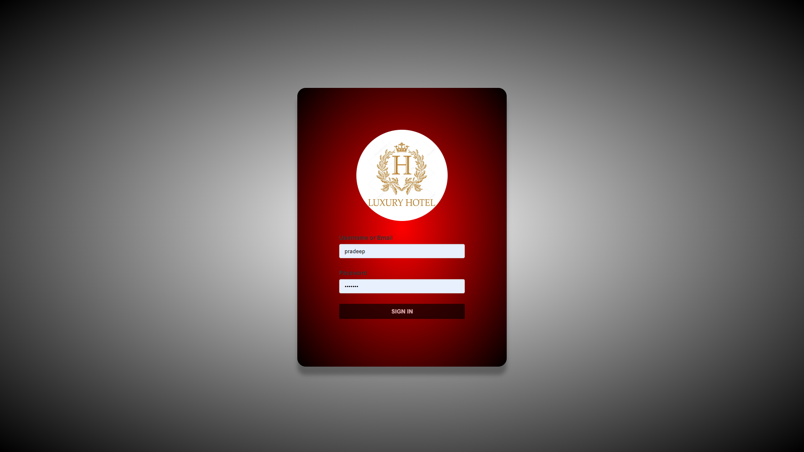

Our Hotel Management system is a software that will be used by hotels and other hospitality businesses to manage their operations. This will include managing reservation, Room management and modification, Keeping records of all the guests, Payment and billing, and Staff management and viewing the hotel statistics and how well the hotel is doing, utilizing OLAP( Online Analytical Processing).

The use of hotel management systems has become increasingly popular in recent years due to the benefits they offer, such as increased efficiency, improved guest experience, and better data management

**Motivation**

The motivation behind developing a hotel management system for hotel staff is to provide an efficient and streamlined process for managing hotel operations. The system is designed to help staff in managing various hotel operations such as room booking, guest check-in and check-out, staff management, complaint management, and overall hotel performance analysis in a centralized location.

The system also provides real-time information on room availability, occupancy rates, and earnings, which can help hotel management make informed decisions. By implementing this system, hotels can improve their overall efficiency, reduce the risk of errors, and provide a better guest experience.

**Goals**

To streamline hotel operations and improve efficiency by automating the booking process and room management.

1. The system aims to simplify the hotel management process, increase staff productivity, and improve the customer experience by providing a streamlined and user-friendly interface for managing hotel operations.
2. To provide staff with a tool that can help them manage their workload and improve productivity. The goal is to create a system that is easy to use, reduces manual effort, and provides real-time data and insights to help make informed decisions to improve the hotel's overall performance.
3. Improving financial management by providing real-time data on room occupancy, earnings, and expenses.
4. To reduce errors and inaccuracies in the booking and billing process by automating these functions.

**Scope**

The scope of this Hotel Management System is to provide a user-friendly interface for the staff of a hotel to manage and monitor the hotel's operations. It includes features such as user authentication, reservation management,guestmanagement, room management, staff management, complaint management, statistics, search bar, and logout.

**Related work**

**1. Hotel Management System** a Case Study of a Hotel in Nigeria by Emmanuel E. Essien and Mfon E. Bassey (2019) This study focuses on the design and implementation of a hotel management system for a hotel in Nigeria. The system includes features such as room booking, customer management, staff management, and inventory management. The study found that the system improved the hotel's efficiency and customer satisfaction.

2. **Development of a Hotel Management System** by A. O. Akinola, A. O. Akinwale, and S. A. Adekanye (2018) This study presents the development of a hotel management system with features such as room booking, customer management, staff management, and inventory management. The system was tested and found to be effective in managing the hotel's operations.

3. **A Proposed Hotel Management System** with Online Reservation System for the Immaculate Conception International College of Arts and Technology by Carl Vincent V. Gatdula, Michael C. Ramirez, and Rodulfo Jr. M. Lornia (2019) This study proposes a hotel management system with an online reservation system for a college in the Philippines. The system includes features such as room booking, customer management, staff management, and inventory management. The study found that the proposed system could improve the college's hotel operations and increase customer satisfaction.

**Application system functionalities**

We have following features implemented:

1. **User Authentication:** The system should allow only authorized users to log in by verifying their username/Email and password.

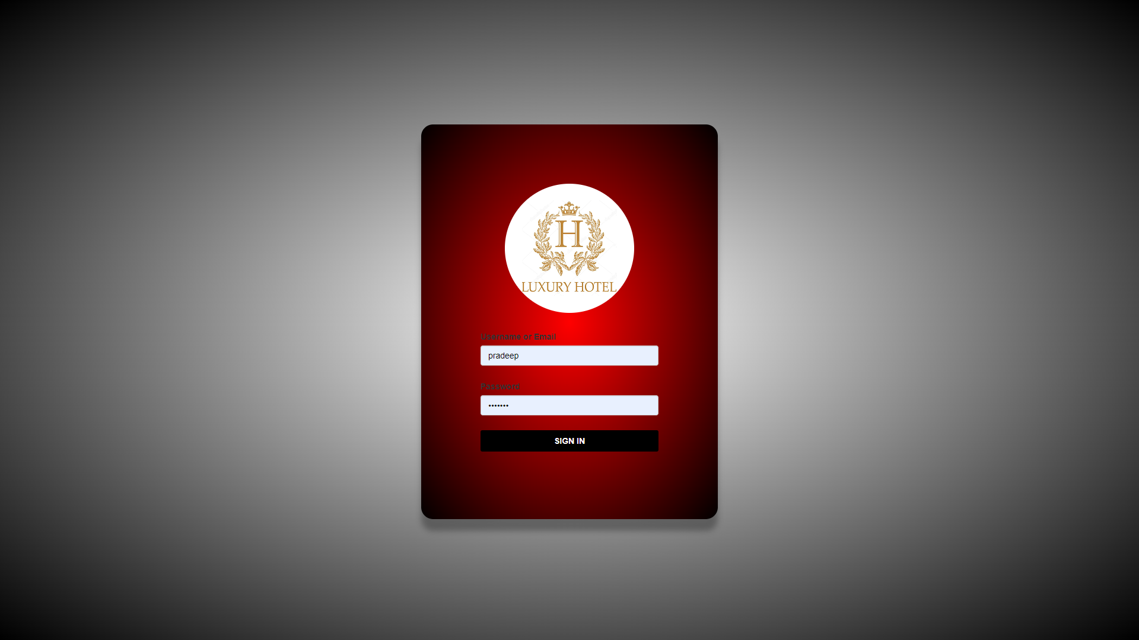

2. **Dashboard:** After logging in, staff members should be directed to a dashboard that provides an overview of the hotel's operations, including the total number of rooms, total number vacant rooms, total number of booked rooms, total reservations, guests checked in, total staff, total number of customers to pay pending payments, total earnings, total pending payment amount to be received and total complaints.

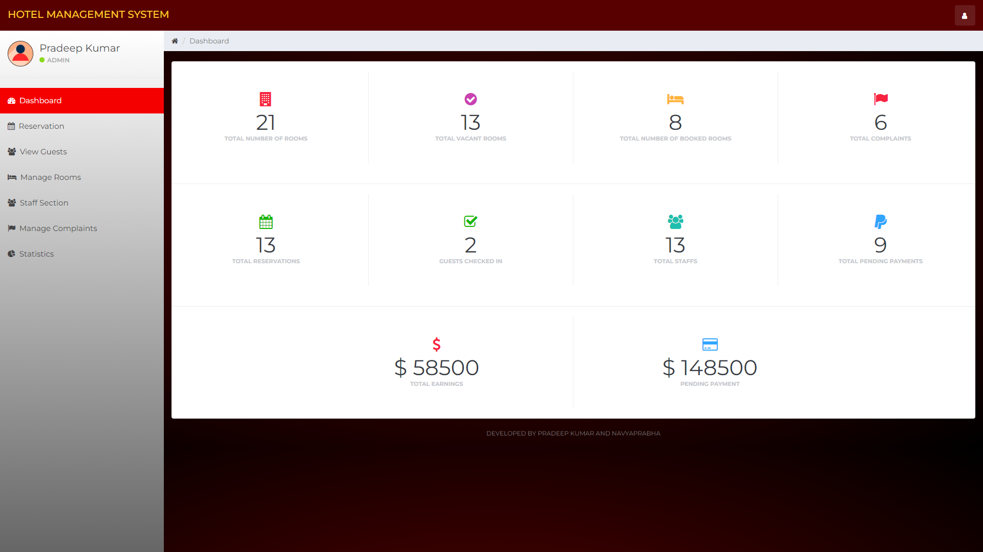

3. **Reservation Management:** Staff members should be able to manage room reservations by adding, editing, and deleting reservations. This includes entering customer details such as First name, Last name, contact information, email address, ID (state id, SSN, passport, driving license) one of the ID mentioned here is sufficient, and Residential address, as well as room type, room number, check-in and check-out dates. Once all the data is entered the system will show the total number of days, price of room for each day, total amount to be paid by customer during checkout. The Replan booking button works the same as the reset button, where staff can enter data again.

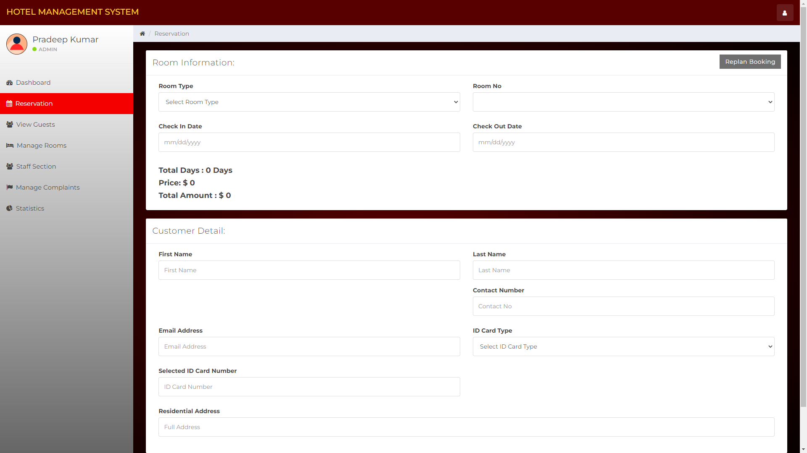

4. **Guest Management:** Staff members should be able to view and manage guest information, including customer ID, customer name, email ID, contact number, room number, room type, room price, check-in, check-out, period of stay, and total bill.

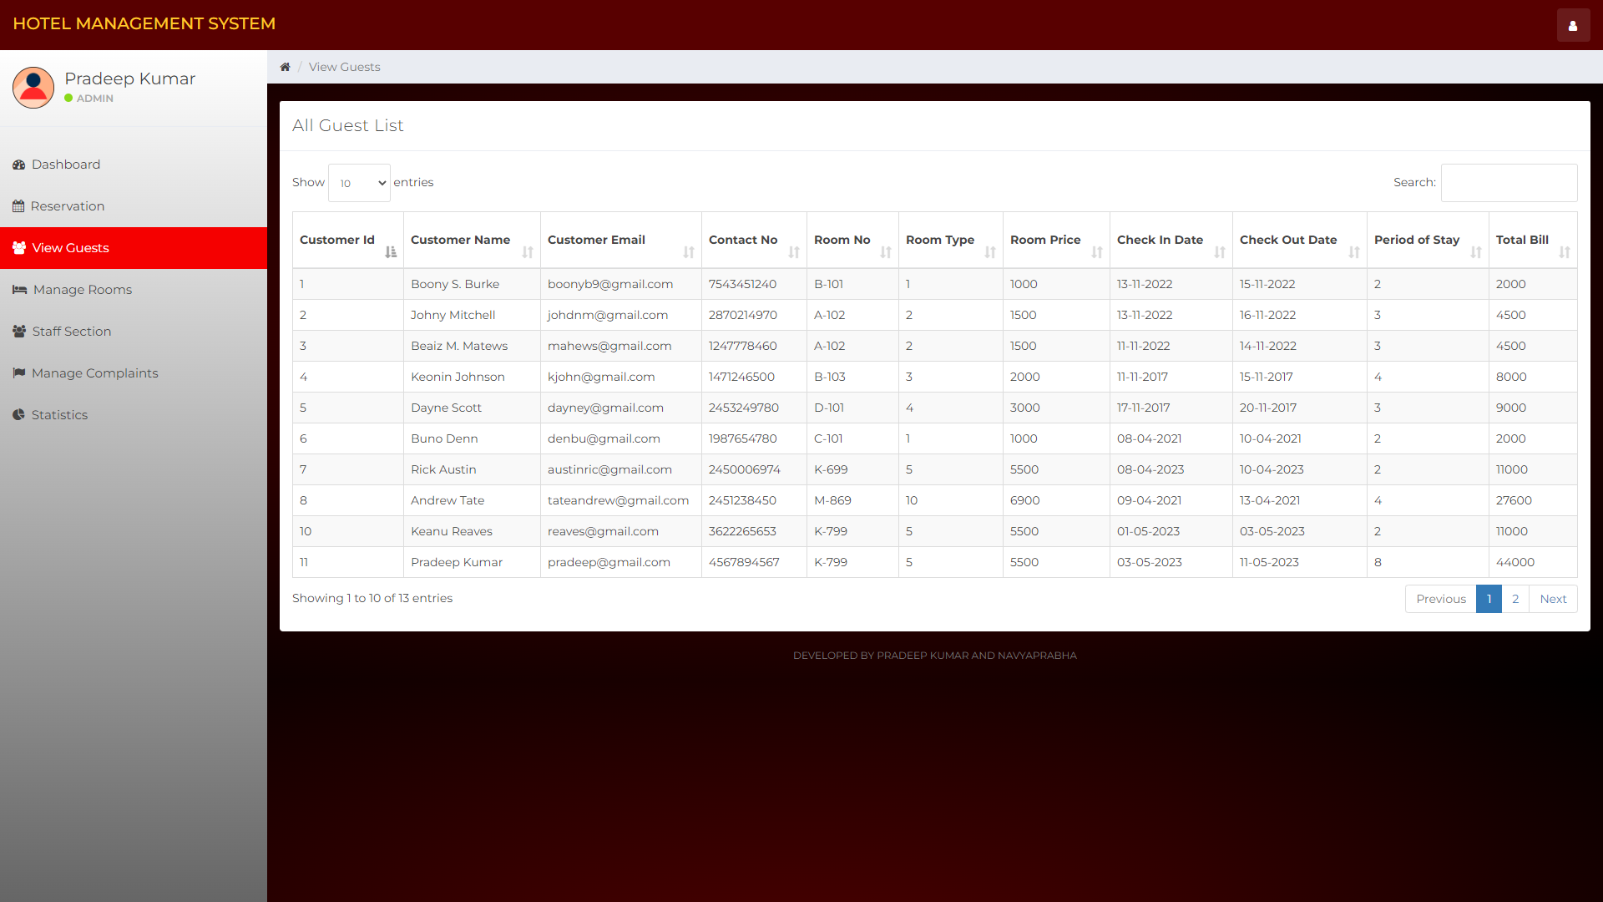

5. **Room Management:** Staff members should be able to manage rooms by viewing availability, adding new rooms, and updating the status of occupied rooms. This includes editing and deleting room details, such as room type and room number. Also, staff will be able to view which room is occupied by which a customer and their complete details like Customer Name, Contact Number, Email, ID Card Type, ID Card number, Address, Remaining Amount ($) to be paid.

There are options like booking status, check-in, check-out. So, then the customer books room the booking status will turn to room booked and check-in status will be just check-in, But once the customer checks-in it will be changed to checked-in. During check-out there will be payment options to pay the bill.

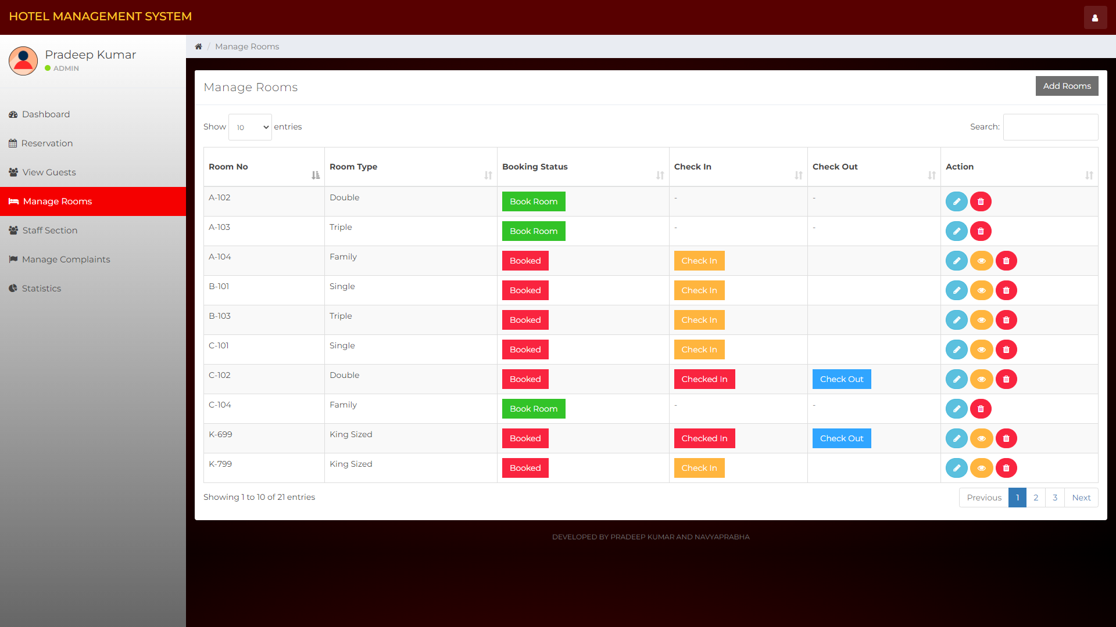

6. **Staff Management:** The system should allow hotel management to manage the details of employees, including their name, position, shift, joining date, and salary. This includes adding new employees, editing employee details, and deleting employee records. It allows managers to change employee shifts. Also, the view option shows complete details about the employee (employee history) where one can see employee name, salary, shift hours they worked on day etc.

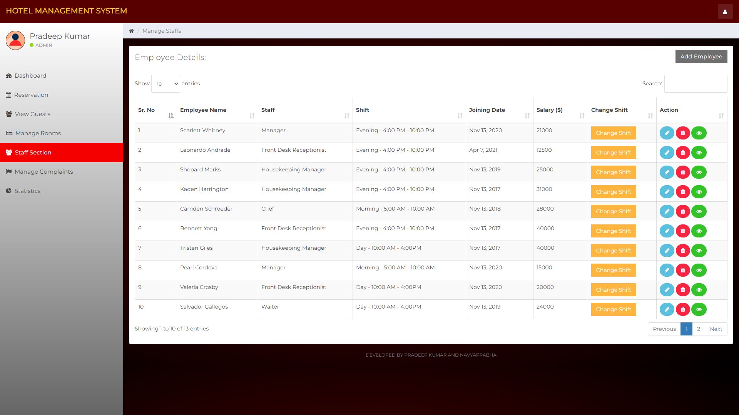

7. **Complaint Management:** The system should allow staff members to manage guest complaints by recording complaint details, including the name of the complainant, complaint type, description, created date, resolved type, and budget. Also, can view details about all the complaints when they open this tab.

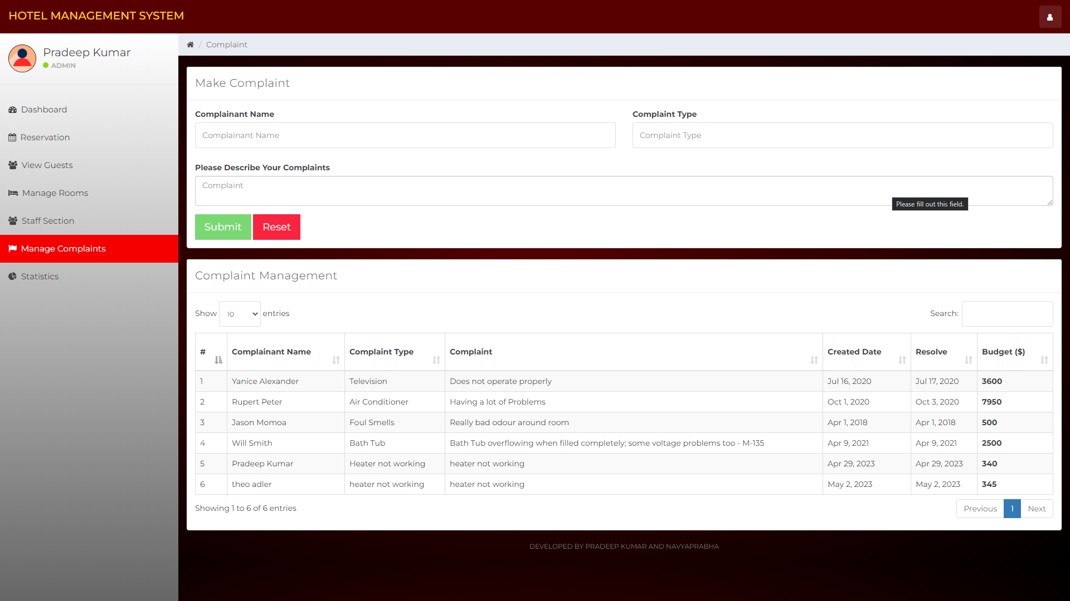

8. **Statistics and OLAP:**

An analytical dashboard using OLAP (Online Analytical Processing) is a powerful tool for business intelligence that allows users to quickly and easily analyze large volumes of data from multiple perspectives. OLAP is used to create multidimensional models of data that can be queried using a variety of analytical techniques, including drill-down, roll-up, slice-and-dice, and pivot tables.

Here are some implementations that we did using analytical queries to build an OLAP-based dashboard.

The system should provide overall statistics about reserved rooms on different days throughout the year, hotel expenses on maintenance, electrical bills, salary and external services, and the number of employees in each department like cleaning, cooking, managing, reception, it manages the complex data such as people their stay at the hotel the their expenses and hotel earnings over multiple years and display the information in a carefully planned structure using pie chart horizontal bar diagrams and calendar data points for easy visualization of the hotel standing and income and expense. This utilizes a lot of analytical queries and report generations.

As shown below

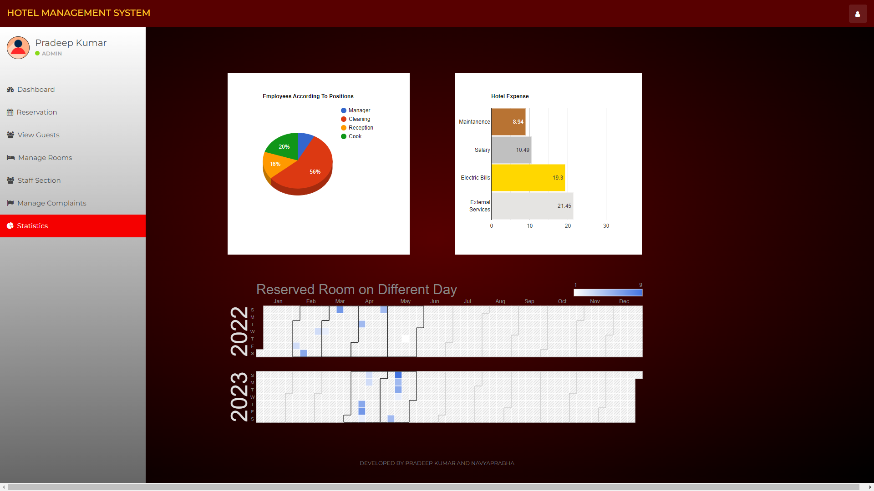

9. **Search Bar:** The system should have a search bar on all pages that allows staff members to quickly search for specific room numbers, guest information, employee details, complaint records in their respective tabs.

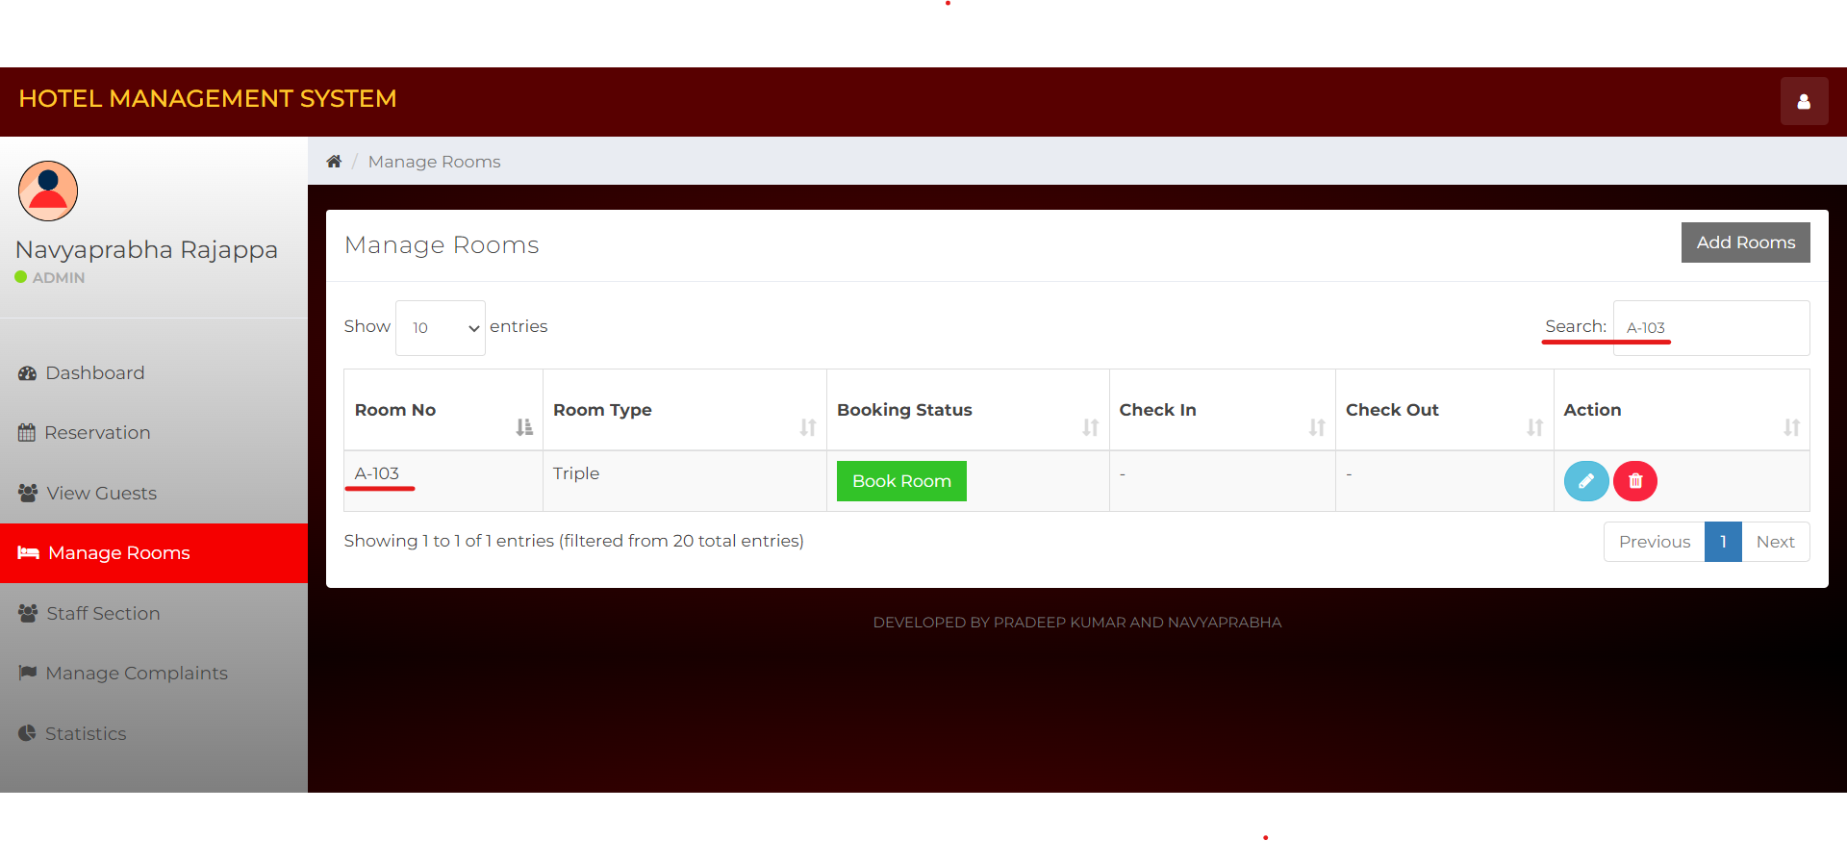

10**. Logout:** The system should allow Staff to log out safely after completing their tasks.

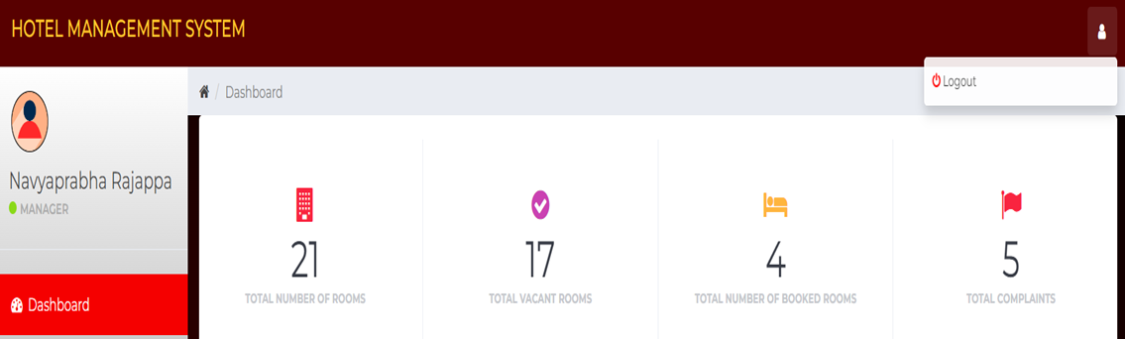

**Conceptual Database Schema**

Shown below are the comprehensive conceptual database schema that has been utilized to develop the system

**Class Diagram**

Given below is the class diagram for the Hotel Management System 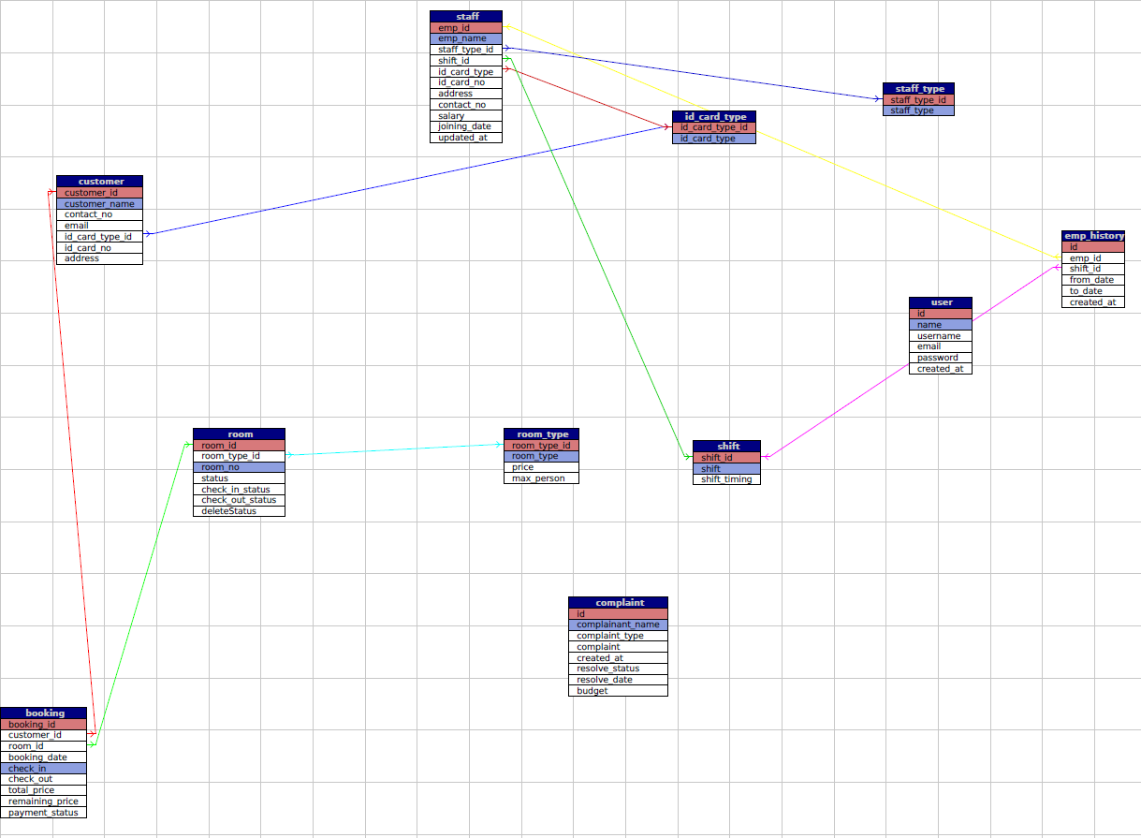

**ERD Diagram:**

ERD diagrams provide a clear and concise way to visualize the structure and relationships of a database

Here is the ER diagram for hotel management system for Hotel Staff

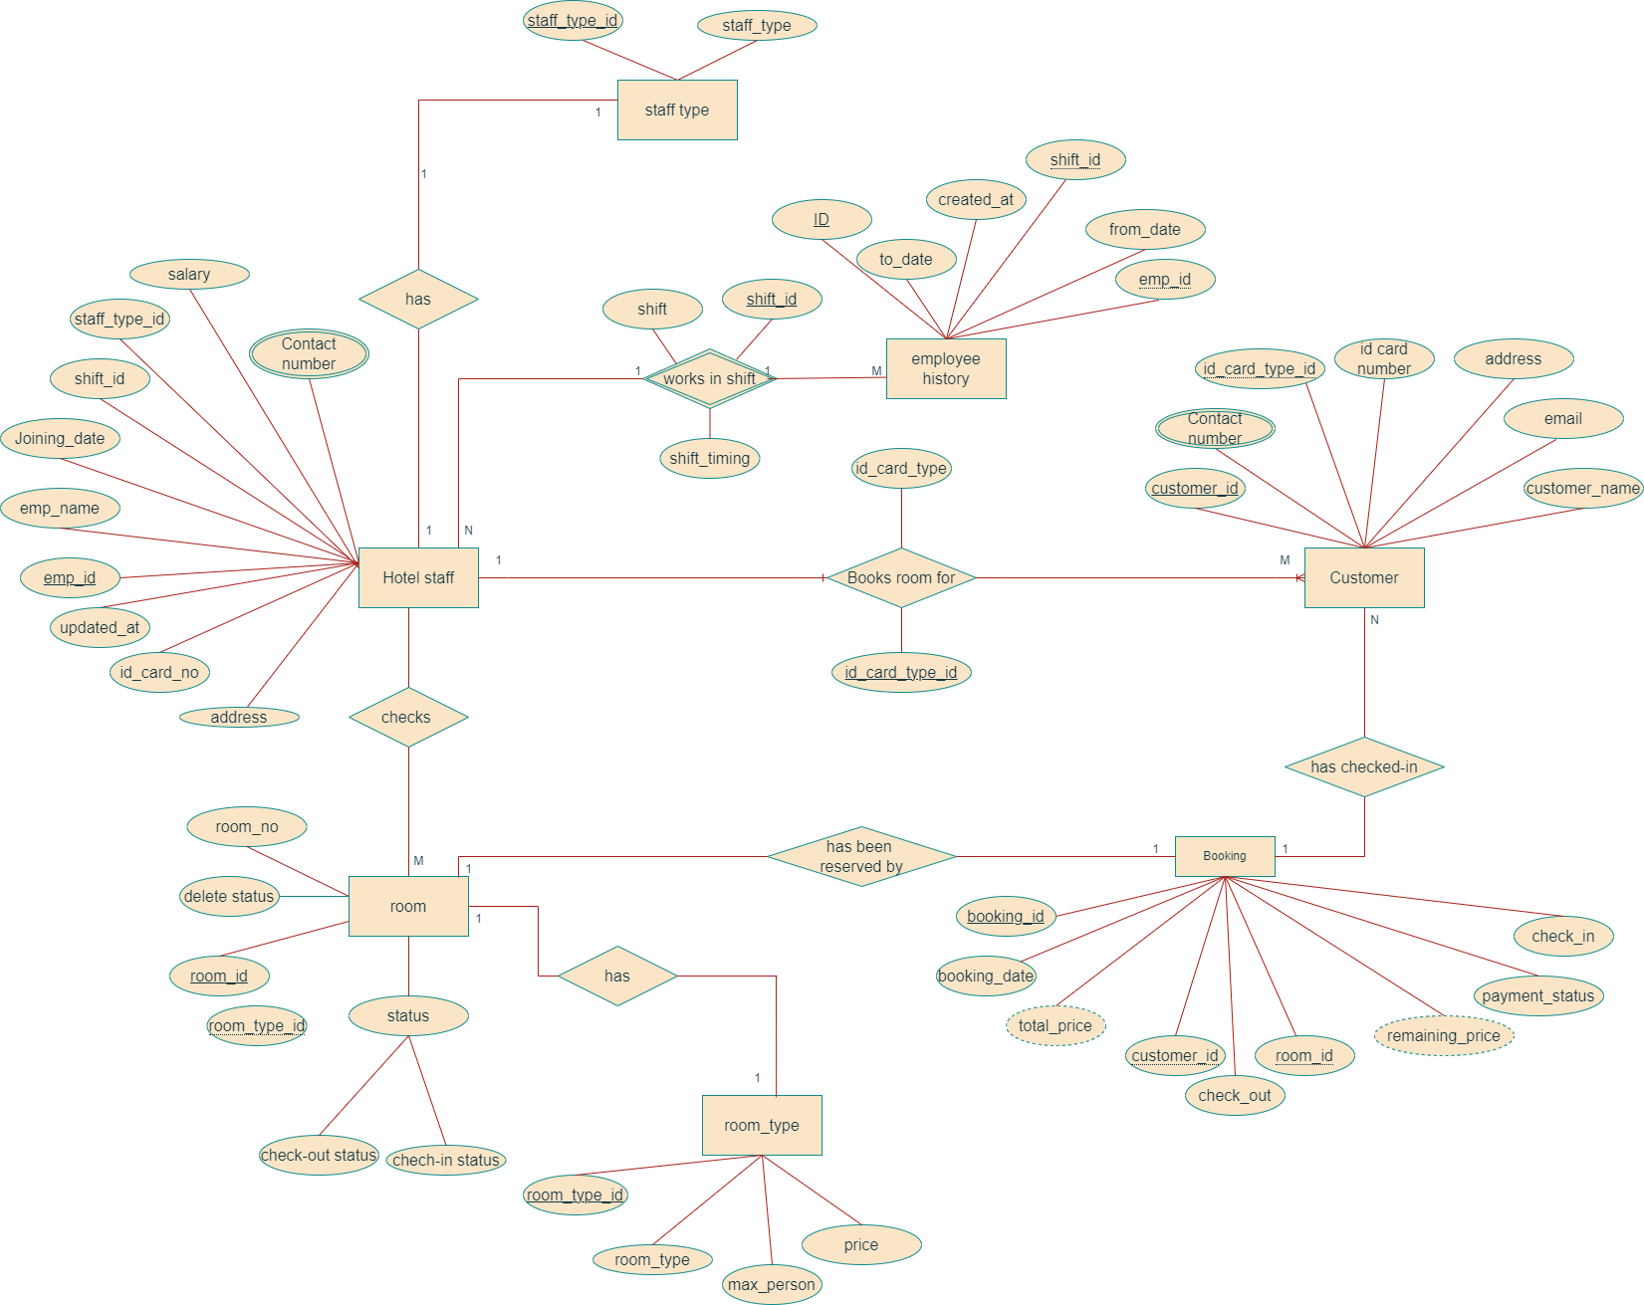

**Logical Database Schema**

Shown below is the comprehensive **Relational schema** that has been utilized to develop the system

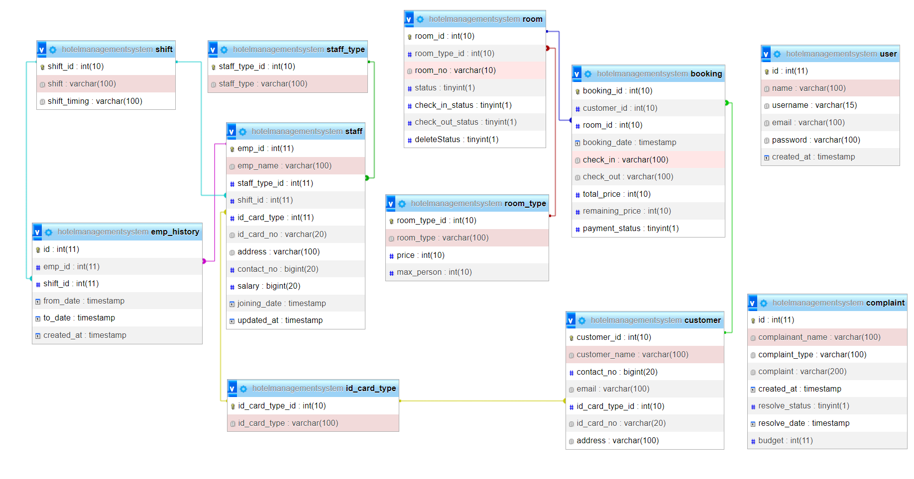

**Physical Database Schema**

Shown below is the comprehensive **Physical Database Schema** that has been utilized to develop the system with choice of data types and index with all the key definitions- primary and foreign keys.

**>Table Structure, Data type and attributes, constraints and indexes**

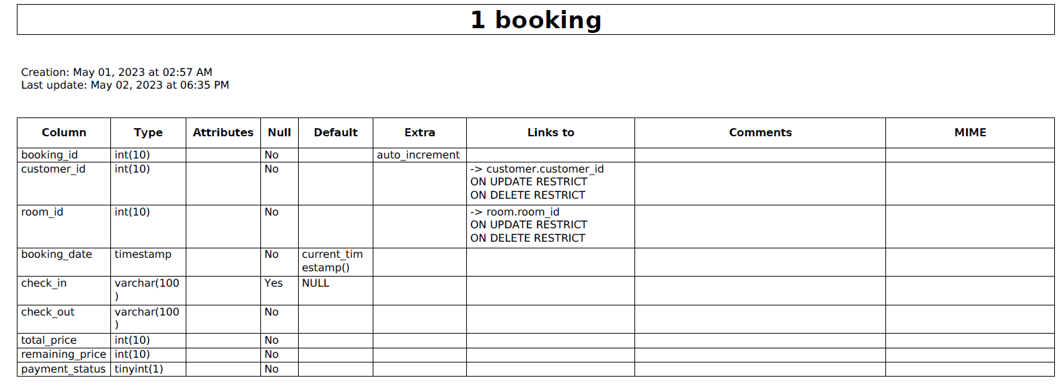

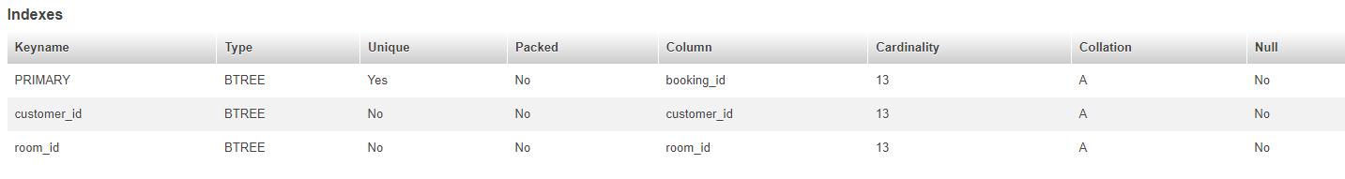

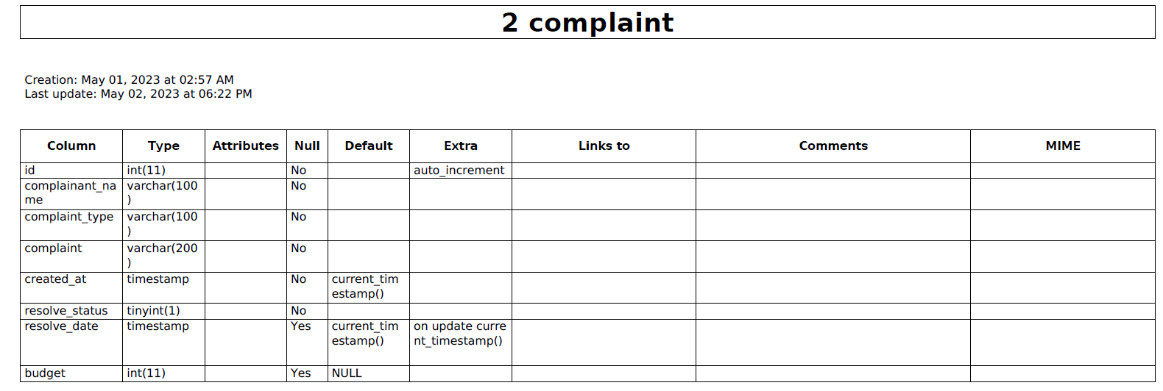



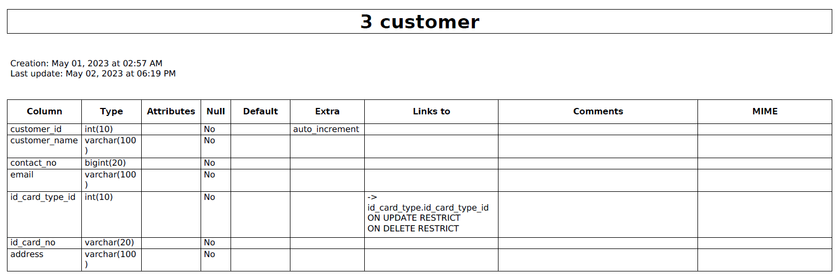

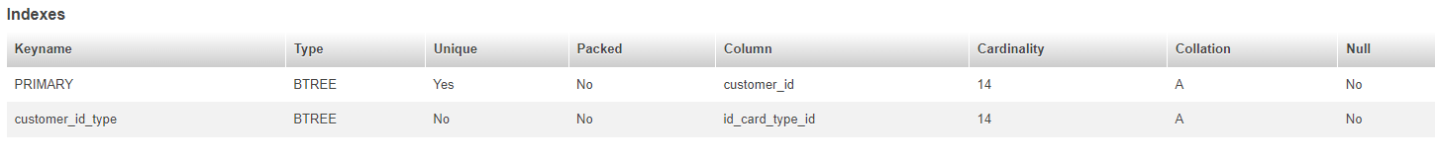

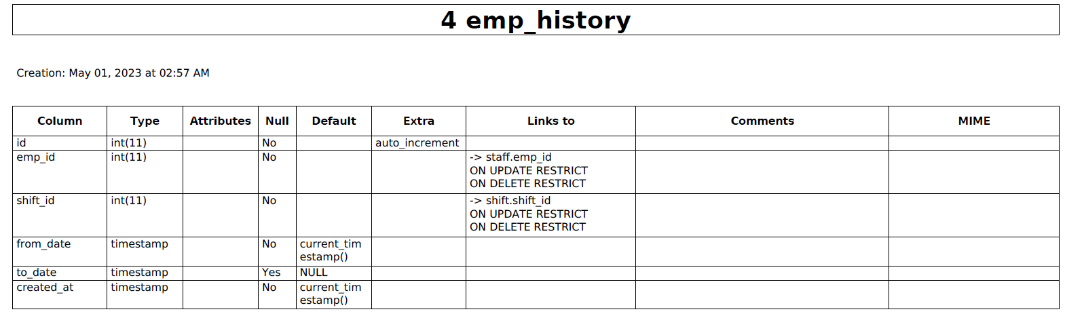

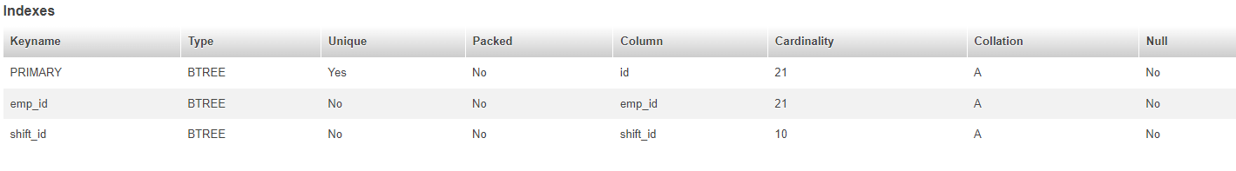

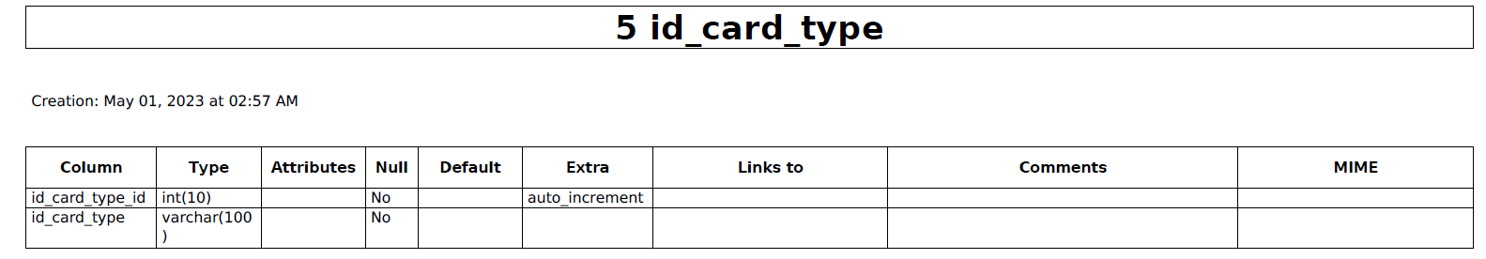



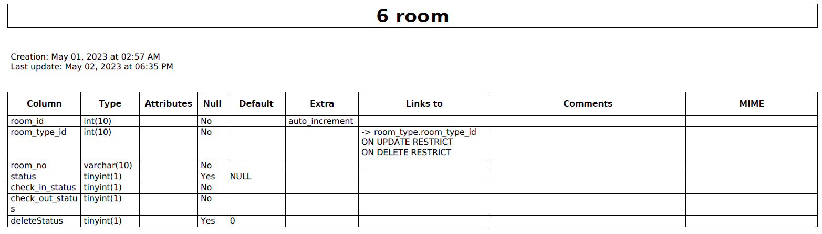

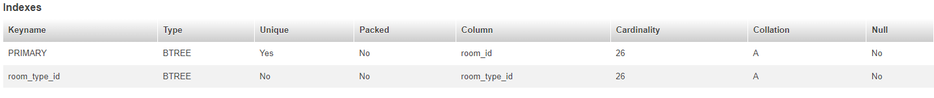

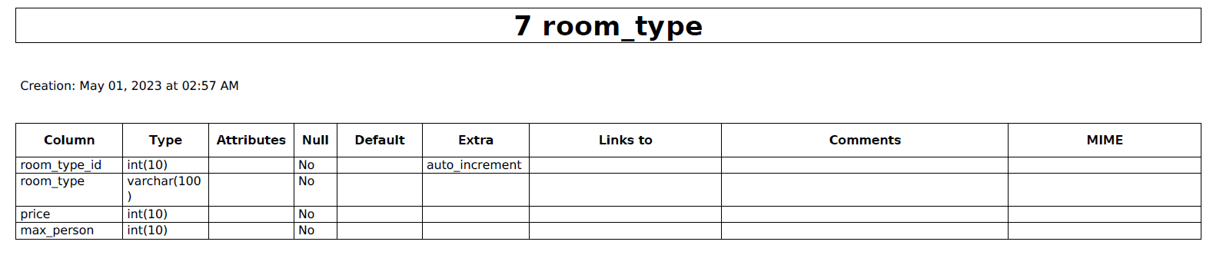



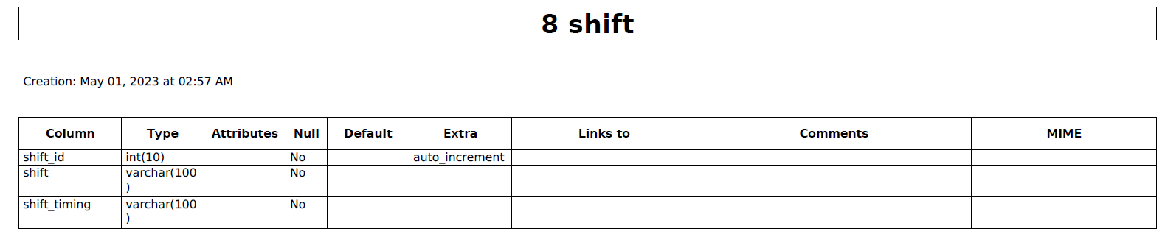



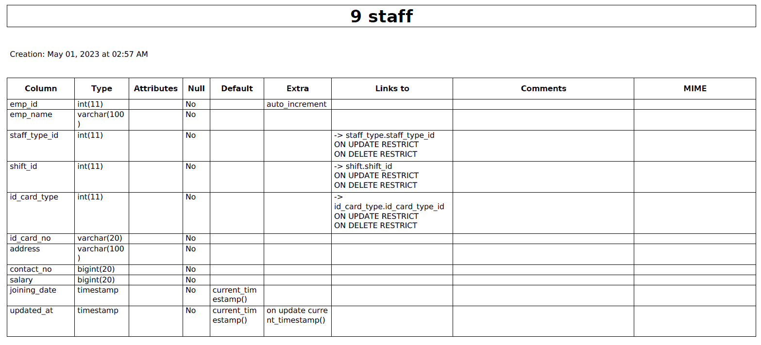

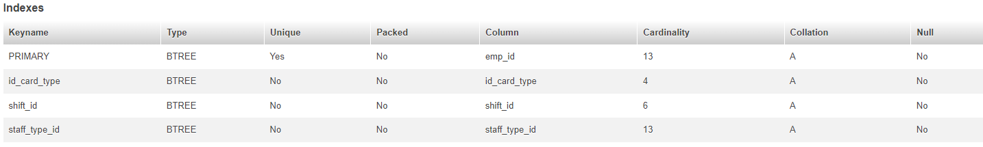

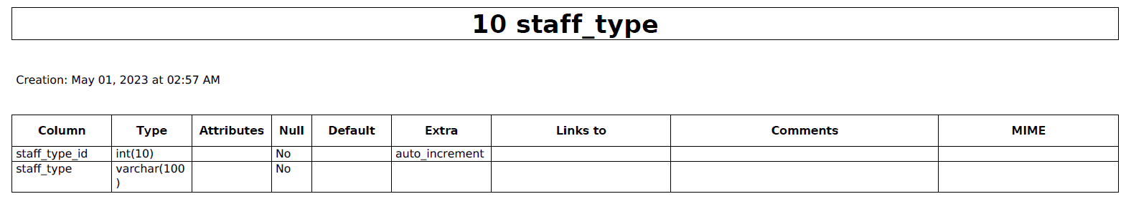



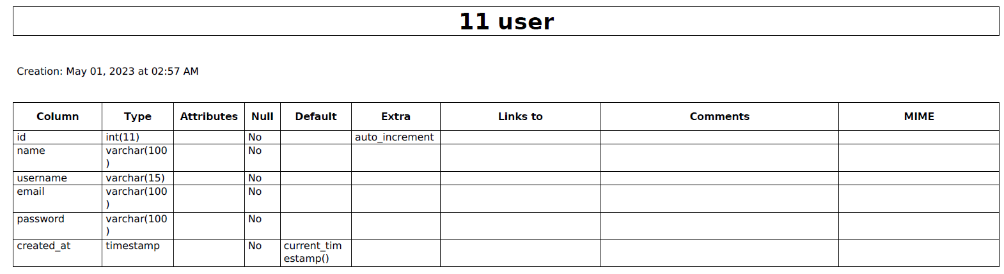



**Database technology**

We chose relational database management system (RDBMS) i.e.MySQL was used to store and manage the hotel's data.

The management of the tables and hotel management system was done using **phpmyadmin** which has MySQL server :   
  
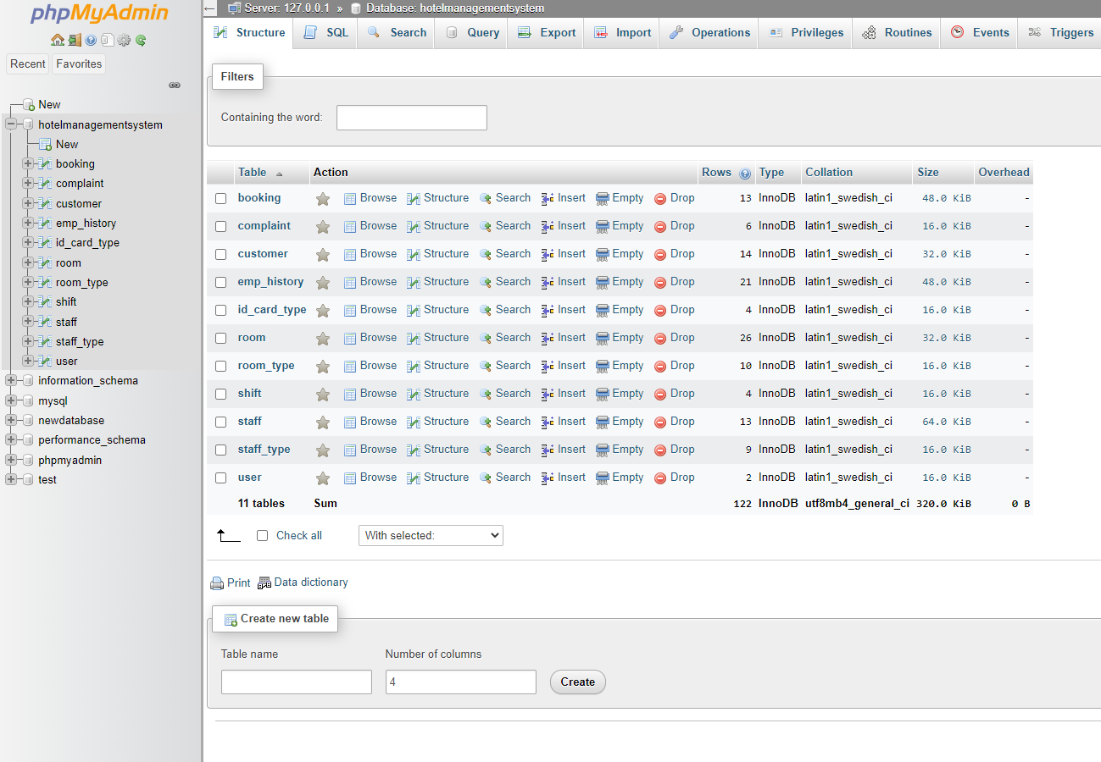

**Prototype for the Hotel Management**

**1. User Authentication:**

* Login page with fields for username/email and password.

Given Below are the login details that can only be used to login to the website :   
  
username: pradeep / kumap02@pfw.edu

password: pradeep

Username: navya / rajan02@pfw.edu

Password : navya

* Authentication checks the user credentials against the database of authorized users.

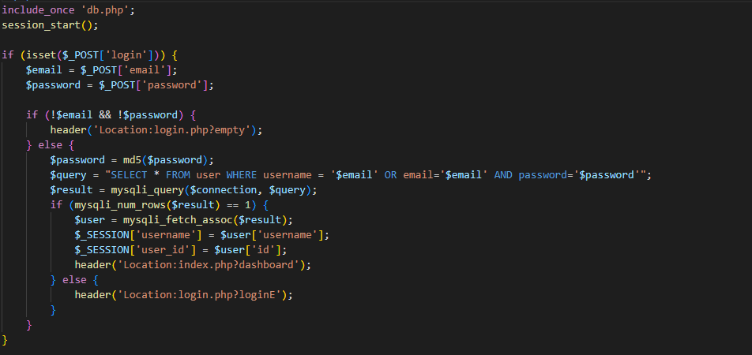

**2. Dashboard:**

* Overview of hotel operations displayed on the dashboard, including:
  + **Total number of rooms**: Displays the total no of rooms in the hotel using the below query

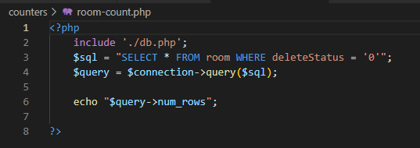

* + **Total number of vacant rooms** : gives the total number of room count using the below query

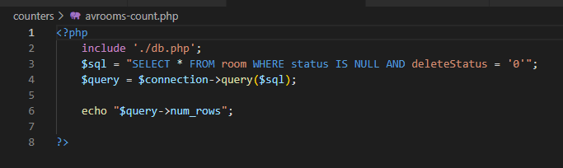

* + **Total number of booked rooms** : Gives the total number of booked rooms using the below query

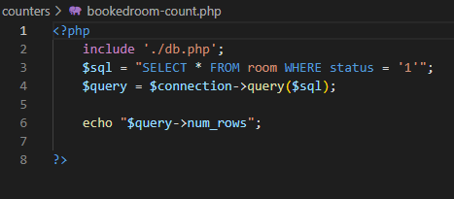

* + **Total reservations** : it gives the total number of reserved rooms so that the hotel staff can easily see the total rooms reserved and evaluate the availability status. It uses the below query to keep track of that.

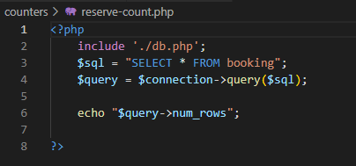

* + **Guests checked in** : It helps keep track of the information regarding the count of guests checked in so that the hotel staff can easily identify how many guests are there in the hotel at any given day. And it is evaluated using the below sql query from the server

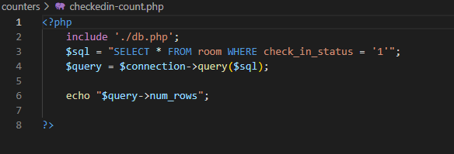

* + **Total staff** : It keeps track of the count of the total hotel staff present and allows the manager to keep track of whether to employ more staff or not. It is evaluated by the below php code which queries this information from the database server

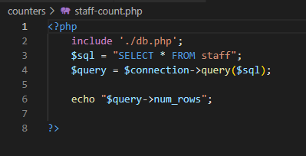

* + **Total number of customers with pending payments** : To display the total number of customers who are checked in and yet to be checked out. Once they are checked out they will make full payment.

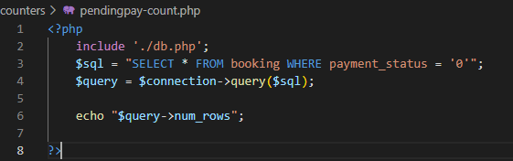

* + **Total earnings** : it is the total earnings that the hotel has made over time and below is the php script which captures this information from the database.

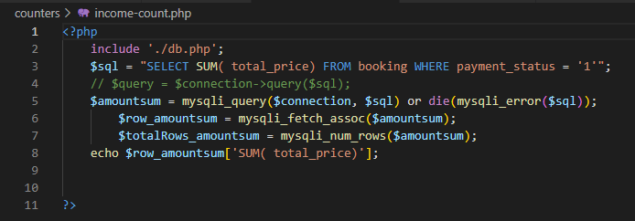

* + **Total pending payment:** It is the pending amount to be received and is displayed using the below script

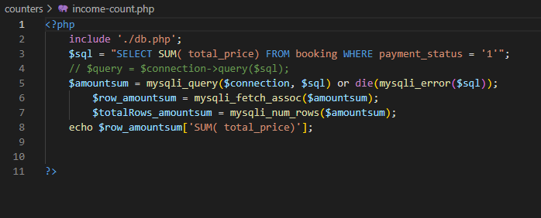

* + **Total complaints** : Displays the total number of complaints using the following query.

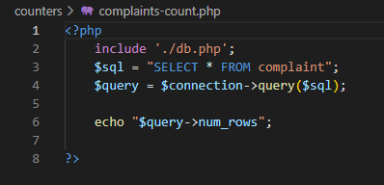

– All the above together form the dashboard with the following information displayed as shown in the below image :   
  
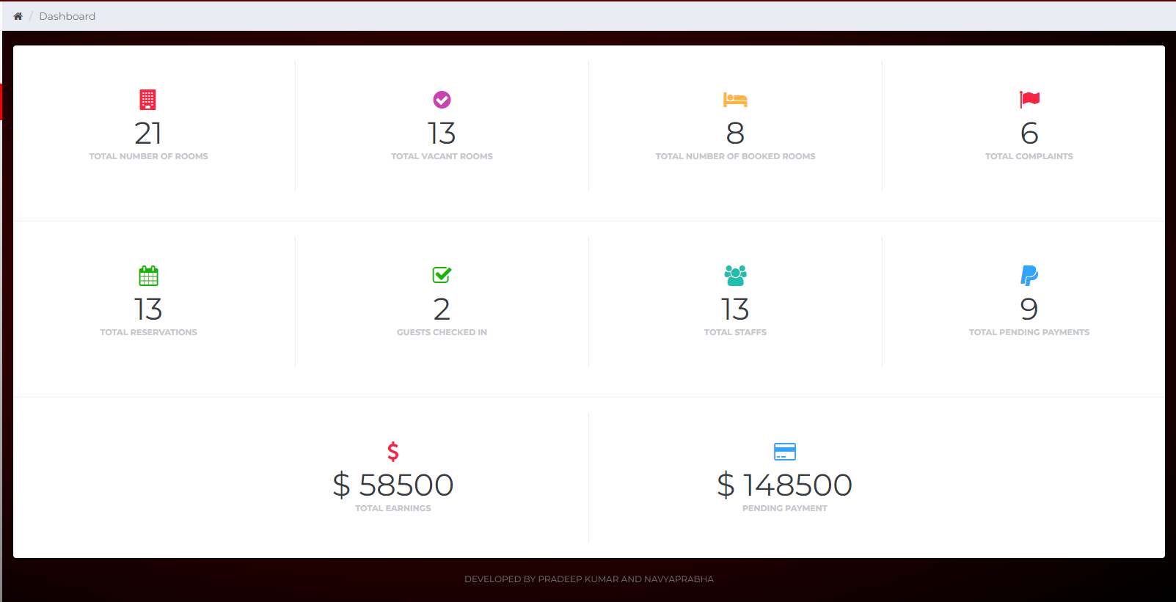

**3. Reservation Management:**

* Page to manage room reservations, with the ability to add, edit, and delete reservations.
* Fields to enter customer details such as First name, Last name, contact information, email address, ID (state id, SSN, passport, driving license), and Residential address.
* Fields to select room type, room number, check-in, and check-out dates.
* Calculations for total number of days, price of room for each day, and total amount to be paid by the customer during checkout.
* A "Replan booking" button to start the process anew.
* Given below is the snapshot of the backend code that helps manage the reservation.

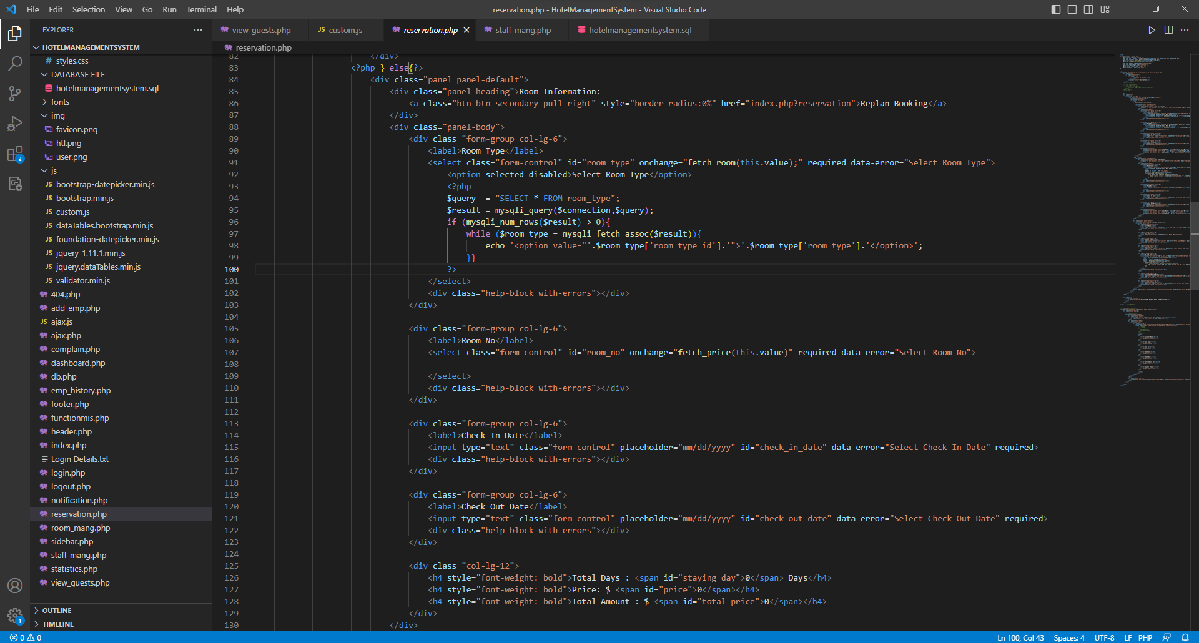

**4. Guest Management:**

* Page to view and manage guest information.
* Fields to display customer ID, customer name, email ID, contact number, room number, room type, room price, check-in, check-out, period of stay, and total bill.
* Below is the snapshot of the code that is used to help manage the guests

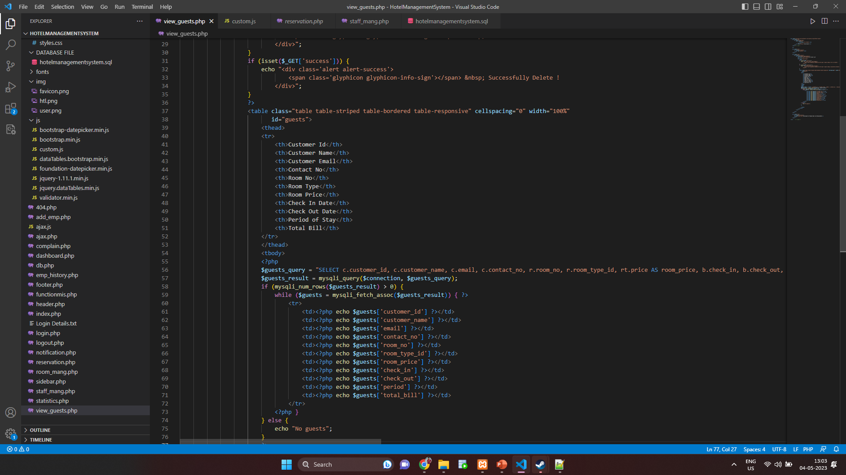

**5. Room Management:**

* Page to manage rooms, with the ability to view availability, add new rooms, and update the status of occupied rooms.
* Fields to edit and delete room details, such as room type and room number.
* Ability to view customer details for occupied rooms, including Customer Name, Contact Number, Email, ID Card Type, ID Card number, Address, and Remaining Amount ($) to be paid.
* Options for booking status, check-in, and check-out.
* Given below is a snapshot for the room management script and query

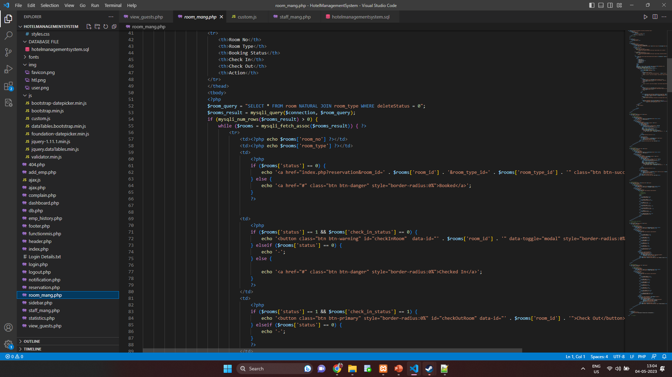

**6. Staff Management:**

* Page to manage employee details, including name, position, shift, joining date, and salary.
* Fields to add new employees, edit employee details, and delete employee records.
* Ability to change employees' shifts.
* "View" option to display complete employee history, including employee name, salary, and shift hours worked on a particular day.
* Given below is the snapshot for the room management section of the website and the associated queries

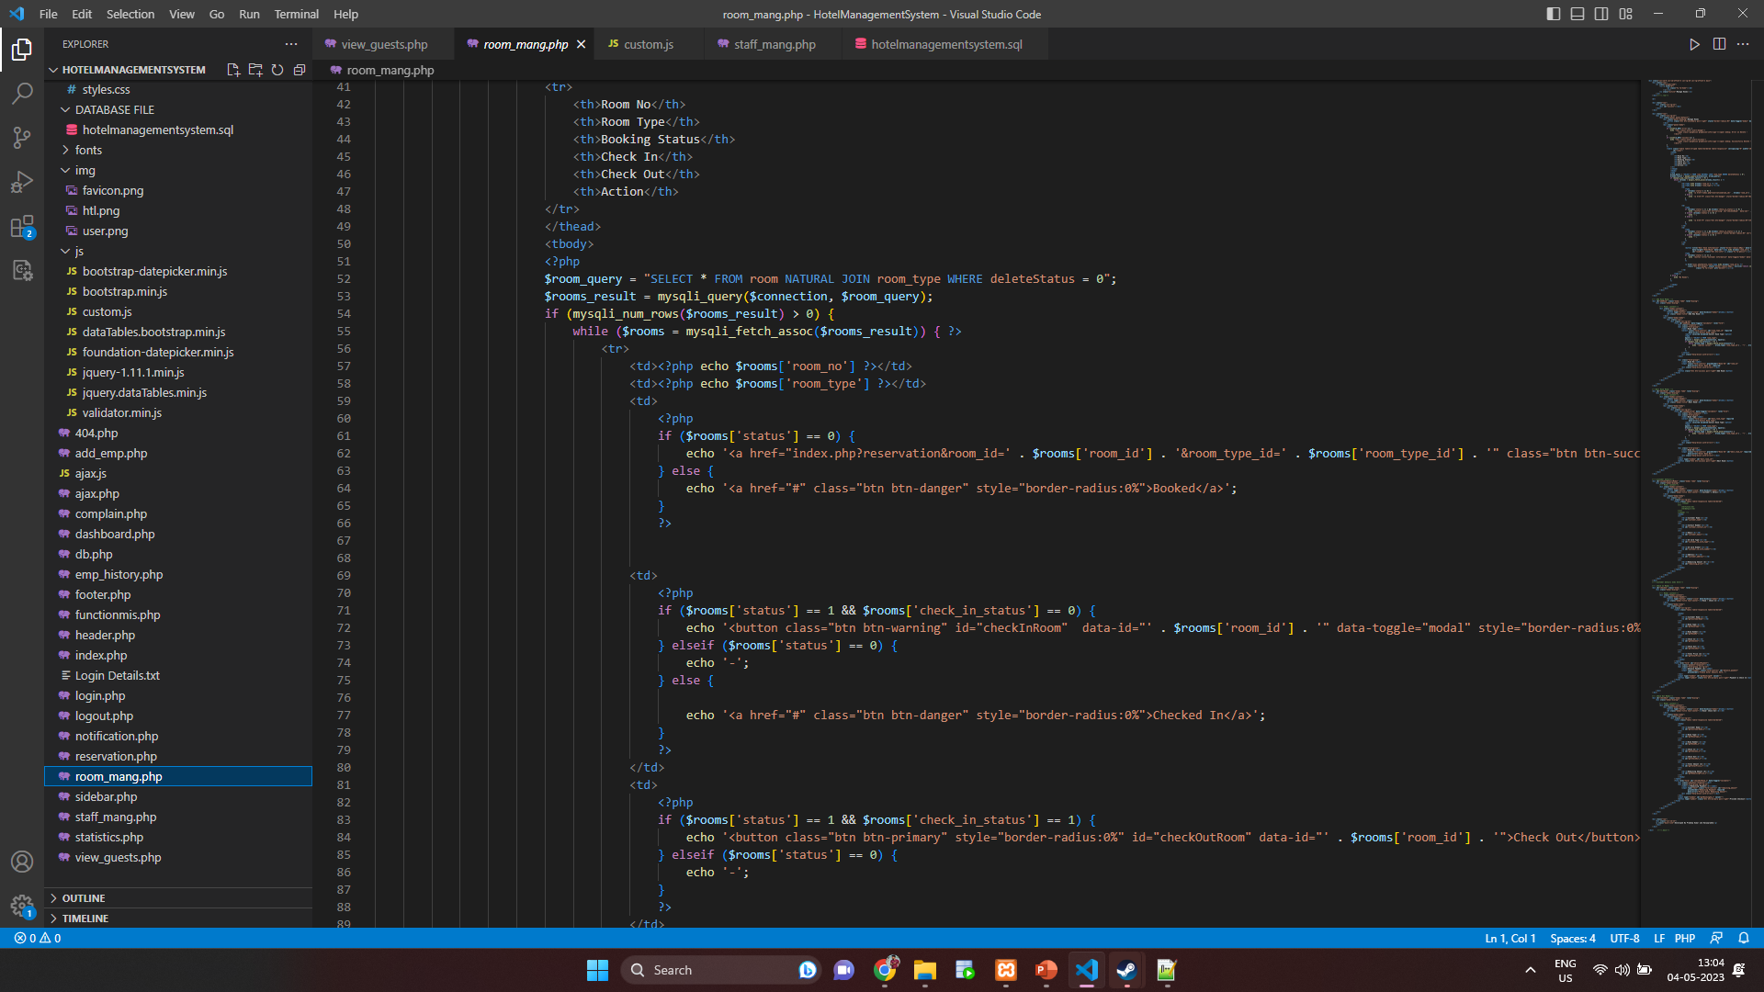

**7. Complaint Management:**

* Page to manage guest complaints, with the ability to record complaint details, including the name of the complainant, complaint type, description, created date, resolved type, and budget.
* Option to view details about all complaints.
* Given below is the snapshot of the scripts and the queries that are used for managing and fetching the complaints using the queries

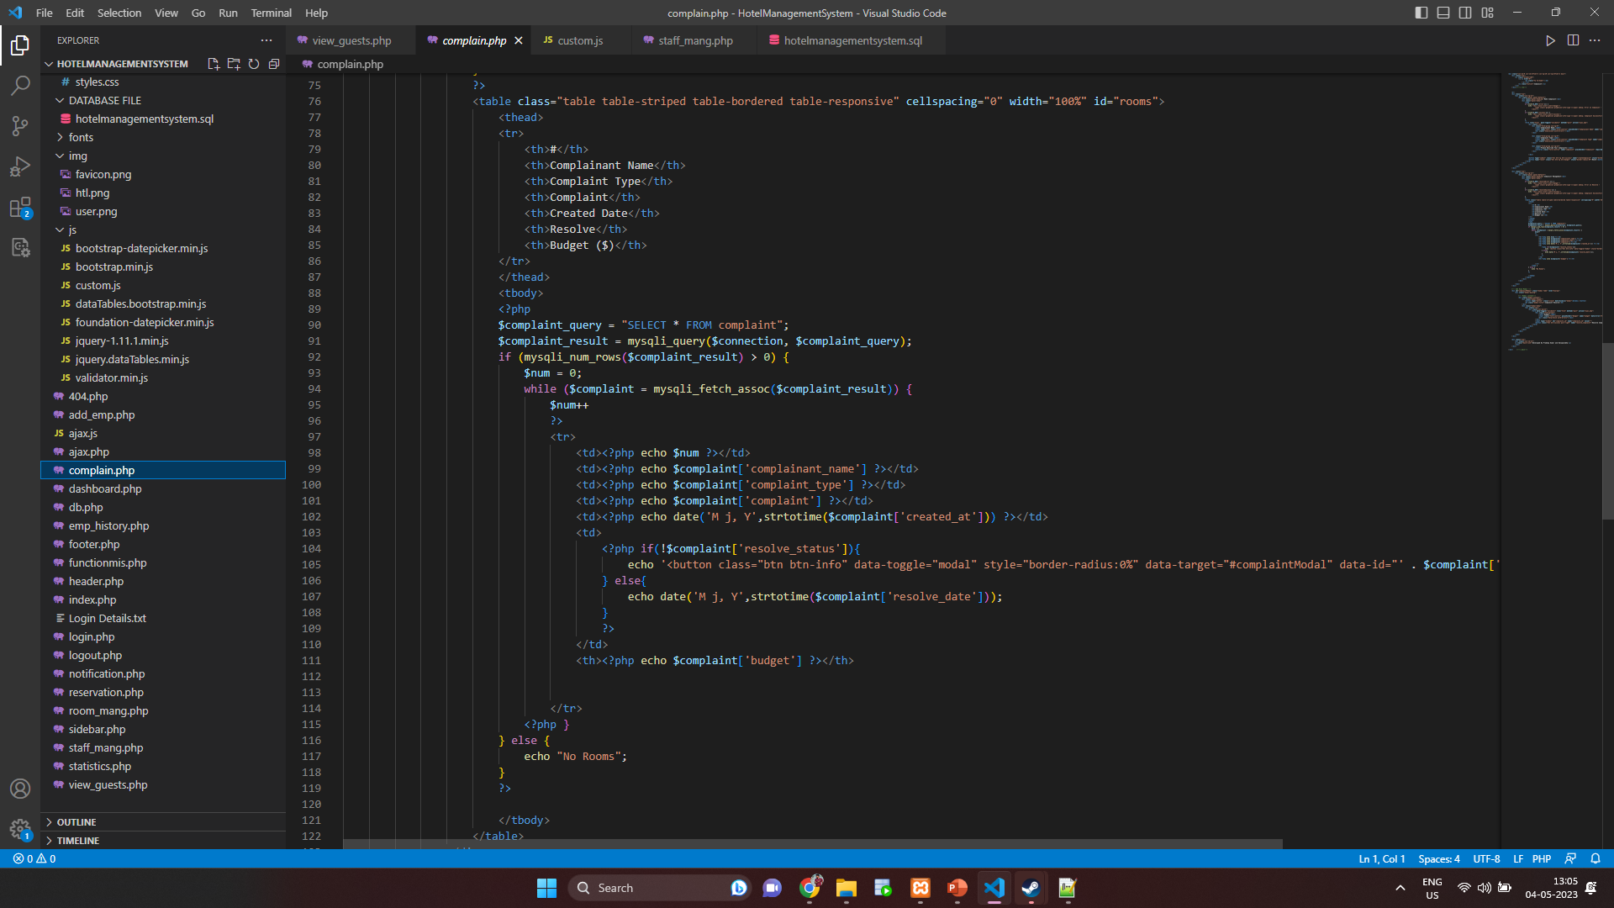

**8. Statistics and OLAP:**

* Page to display overall statistics about reserved rooms on different days throughout the year, hotel expenses on maintenance, electrical bills, salary and external services, and the number of employees in each department like cleaning, cooking, managing, reception.
* Utilizes OLAP to analyze the data in the database and perform complex operations to create statistical charts and diagrams to provide the current hotel revenue, statistics such as the staff demography and expenses.
* Given below is the snapshot of the queries and script that allows this information processing

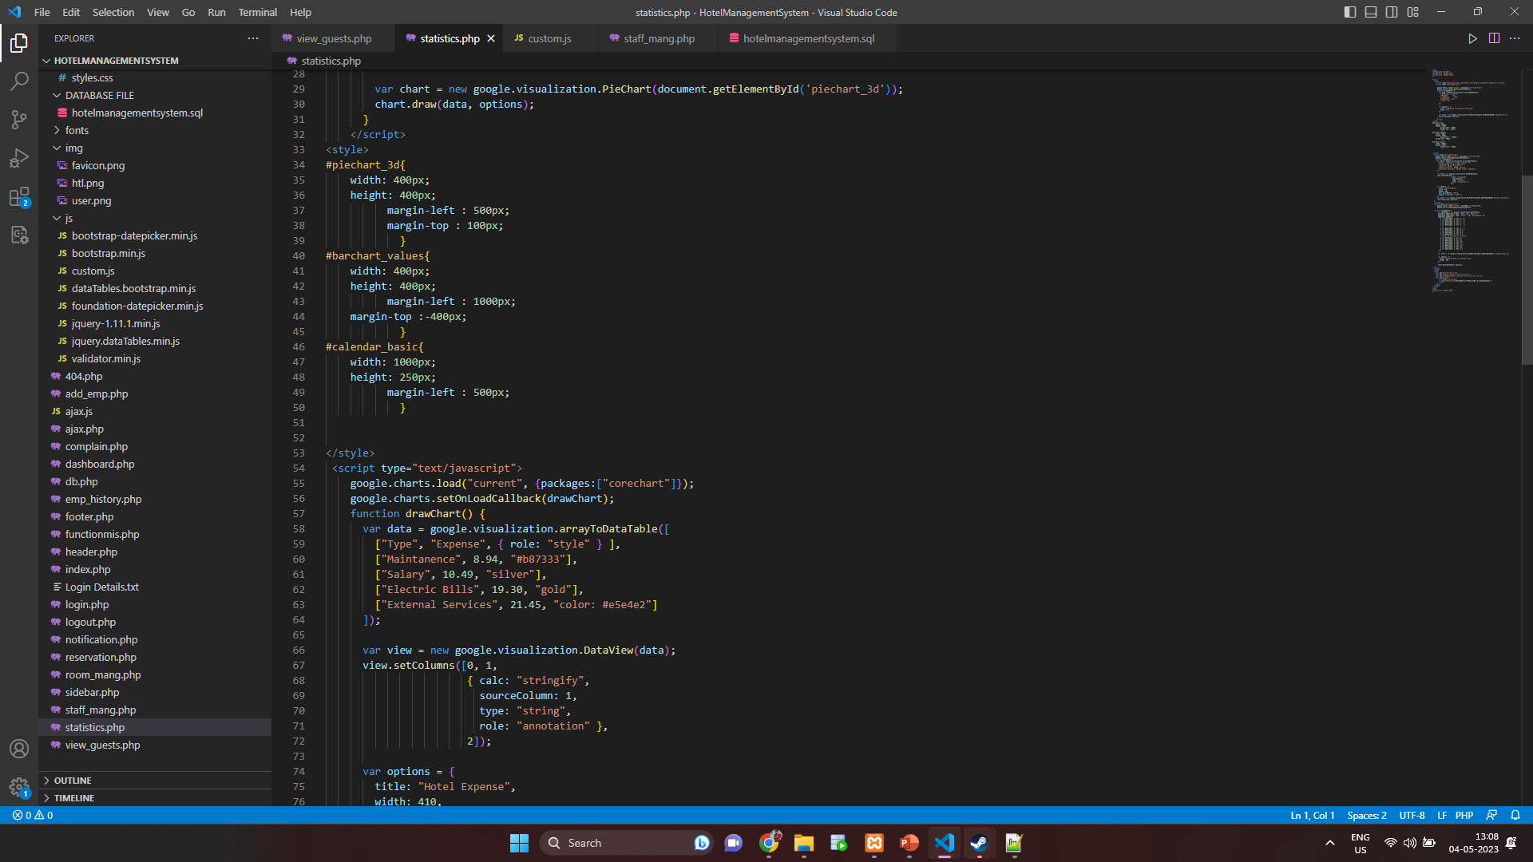

**9. Search Bar:**

* A search bar on all pages to allow staff members to quickly search for specific room numbers, guest information, employee details, and complaint records in their respective tabs.

**10. Logout:**

* Ability for staff to log out safely after completing their tasks.

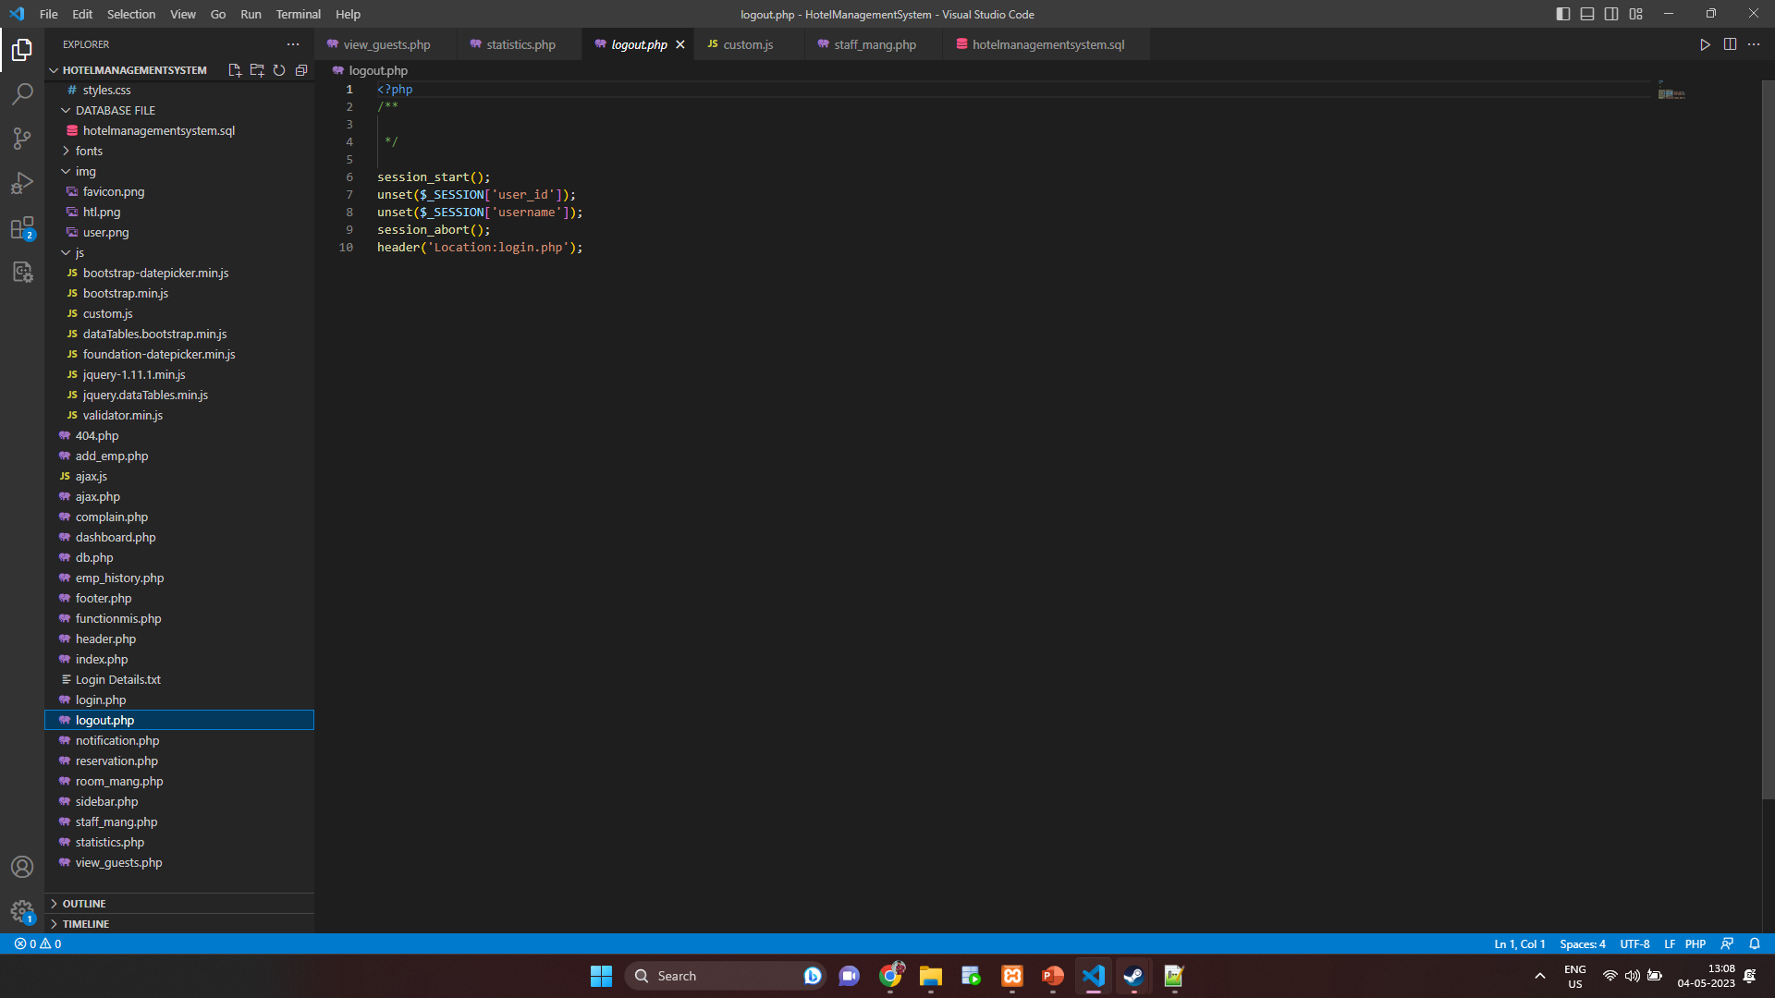

**System Architecture**

We have implemented a three-tier architecture with a web server.The first tier, also known as the presentation layer, is the user interface that staff members use to interact with the system. This layer is implemented using PHP, HTML, and CSS. The web pages will be served from the Apache web server, and the PHP scripts will connect to the database to retrieve and display data on the web pages.

The second tier, also known as the application layer, will handle the business logic of the system, such as processing user inputs, validating data, and retrieving data from the database. This layer will be implemented using PHP and will communicate with the presentation layer and the data layer.

The third tier, also known as the data layer, will handle data storage and

retrieval from the database. MySQL database will be used to store all the data related to guests, reservations, rooms, employees, and complaints. The data layer will communicate with the application layer to retrieve and store data in the database.

The web server, which is Apache in this case, acts as the interface between the presentation layer and the application layer. The web server serves the PHP files to the user's web browser, and the PHP files use the MySQL database to store and retrieve data.

Below shown is our system architecture

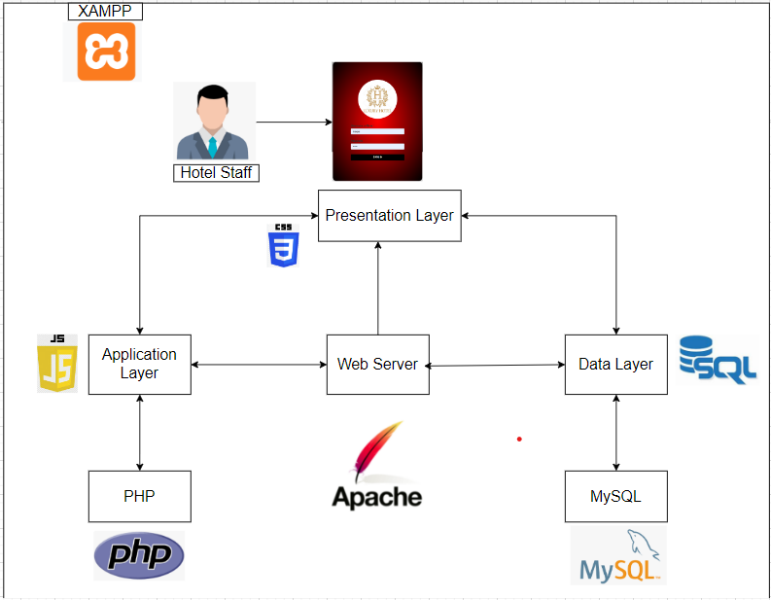

**Development environment**

**Backend:**

* Programming Language: PHP (version 7.4 or higher)
* Web Server: Apache (version 2.4 or higher)
* Database Management System: MySQL, SQL (version 8.0 or higher)
* Database API: PDO (PHP Data Objects)

**Frontend:**

* HTML, CSS, JavaScript, Font Awesome library.

**Software Stack:**

* Operating System: **Windows**
* Local Development Environment: XAMPP (version 8.0.11 or higher)

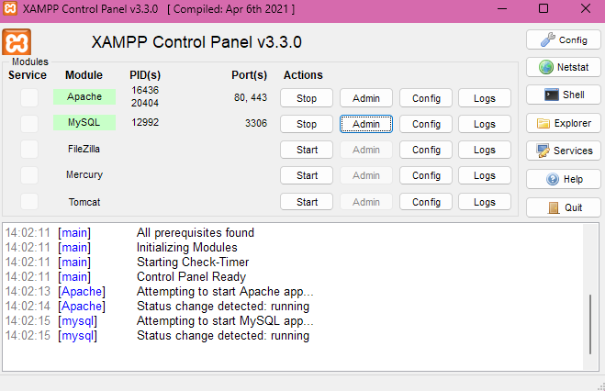

Here is a brief explanation of each component in the development environment:

1. **PHP:** PHP is a widely used server-side scripting language that is used to create dynamic web pages. It is the primary language used in this hotel management system.

2. **Apache:** Apache is a widely used web server that can serve web pages to clients over the internet. It is used to host the hotel management system and serve web pages to users.

3. **MySQL:** MySQL is an open-source relational database management system (RDBMS) that is used to store and manage data. It is used to store all data related to the hotel management system, such as customer information, room reservations, employee details, and more.

4. **PDO:** PDO (PHP Data Objects) is a PHP extension that provides a data-access abstraction layer, allowing developers to write code that can work with a variety of databases, including MySQL. It is used to interact with the MySQL database in the hotel management system.

5. **HTML, CSS, JavaScript:** These are standard web technologies used for creating the frontend of the hotel management system. HTML is used for creating the page structure, CSS is used for styling the pages, and JavaScript is used to create interactive features such as dropdown menus and modal dialogs.

6. **Windows or Linux:** The hotel management system can be developed on either the Windows or Linux operating systems. Both operating systems can run the necessary software components.

7. **XAMPP:** XAMPP is a free and open-source software package that includes Apache, MySQL, and PHP, as well as other components such as phpMyAdmin and OpenSSL. It is used as a local development environment for creating and testing the hotel management system before it is deployed to a live web server.

8. **SQL** - SQL (Structured Query Language) is a standard programming language used to manage and manipulate relational databases. It is used for tasks such as creating, updating, and querying databases, as well as managing access control and user permissions.

9. **Font Awesome library –** Font Awesome is a popular open-source icon library that provides scalable vector icons that can be customized using CSS. It includes a wide range of icons, such as social media icons, UI icons, and various other icons for web development.

Overall, this development environment provides a robust and reliable platform for creating a fully functional hotel management system.

**Working Prototype**

Shown below are images of the working prototype that were also demonstrated in the class(in-person) presentation:

**Login Page:**

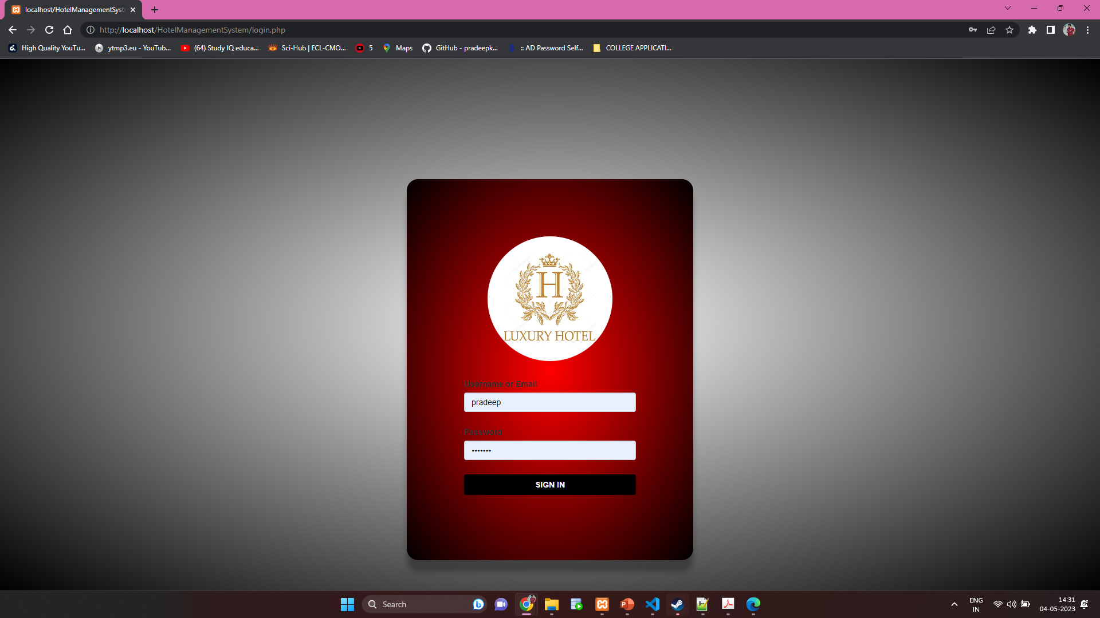

**Post Booking view customer details:**

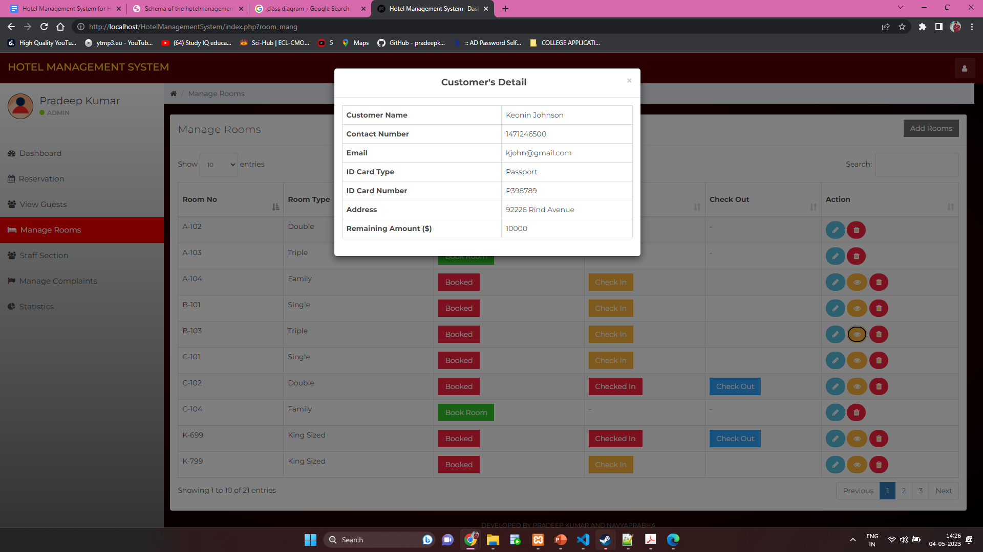

**During Check In:**

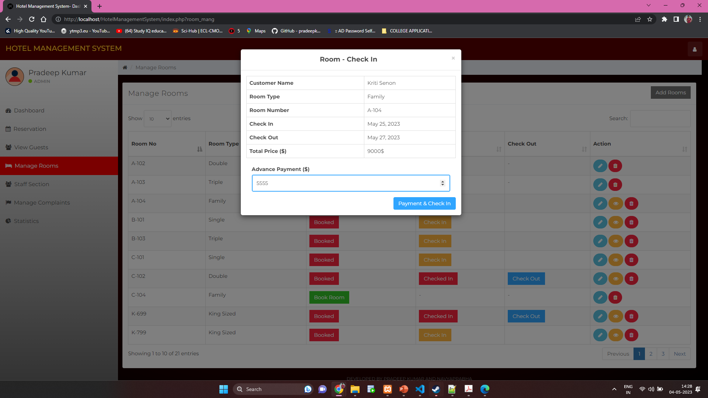

**During Checkout :**

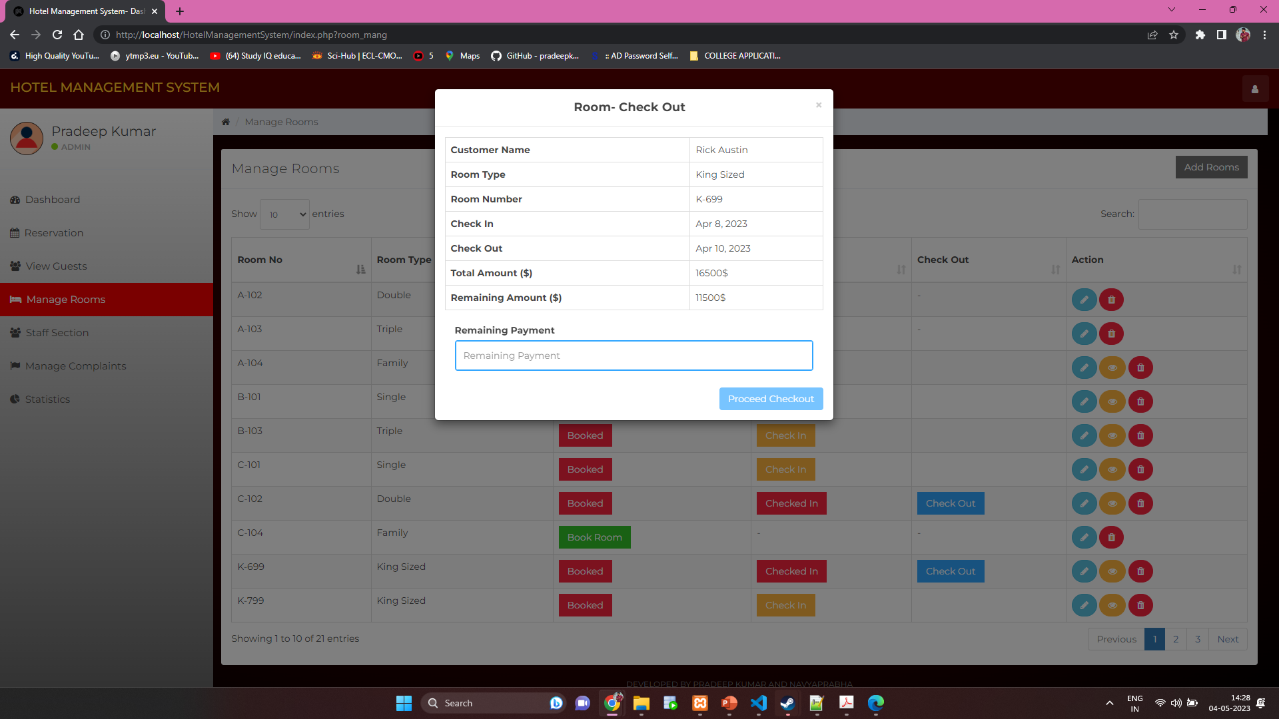

**Staff Management: Change shift feature :**

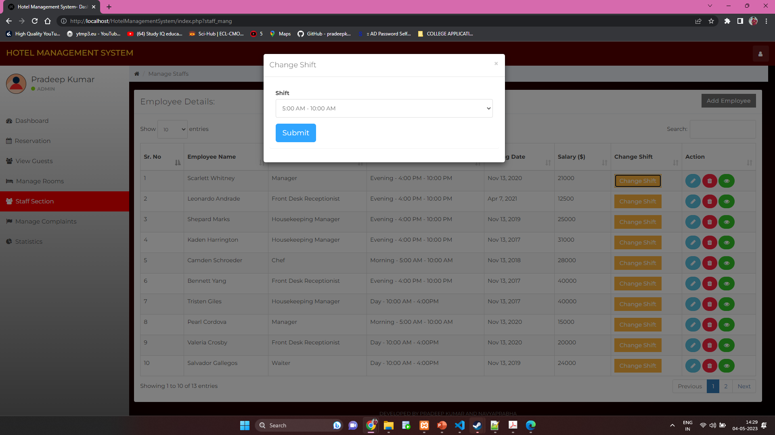

**Edit Staff Details :**

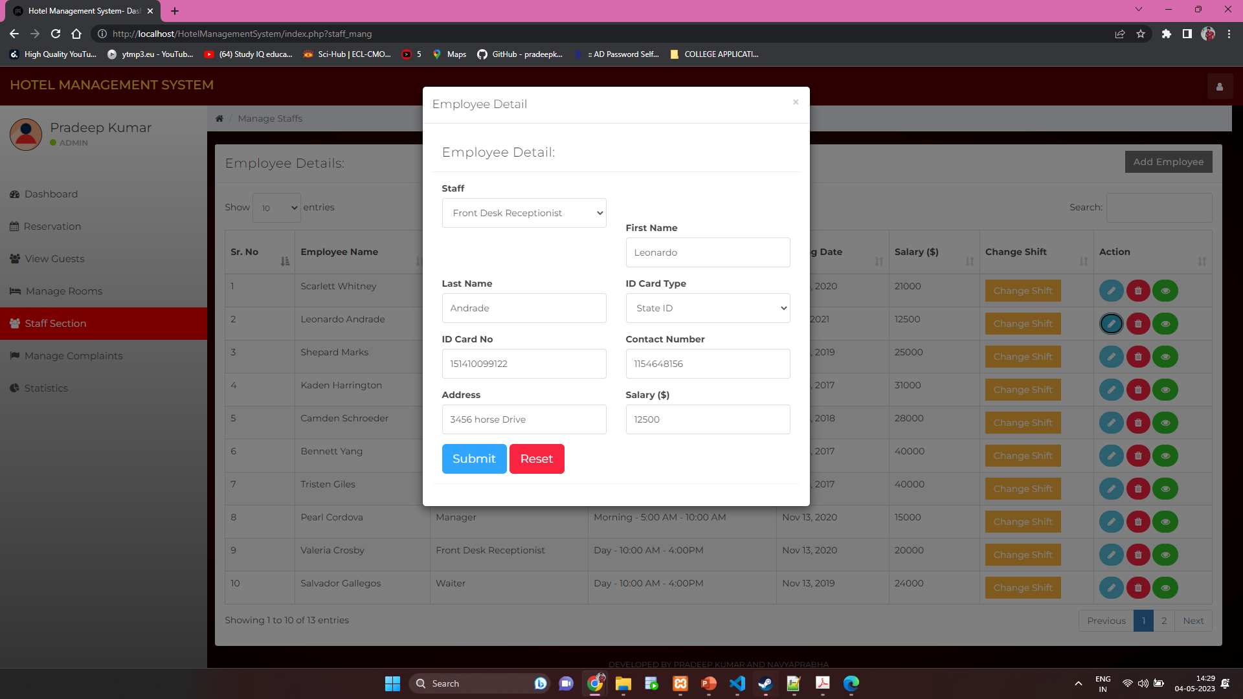

**View Employees Work History:**

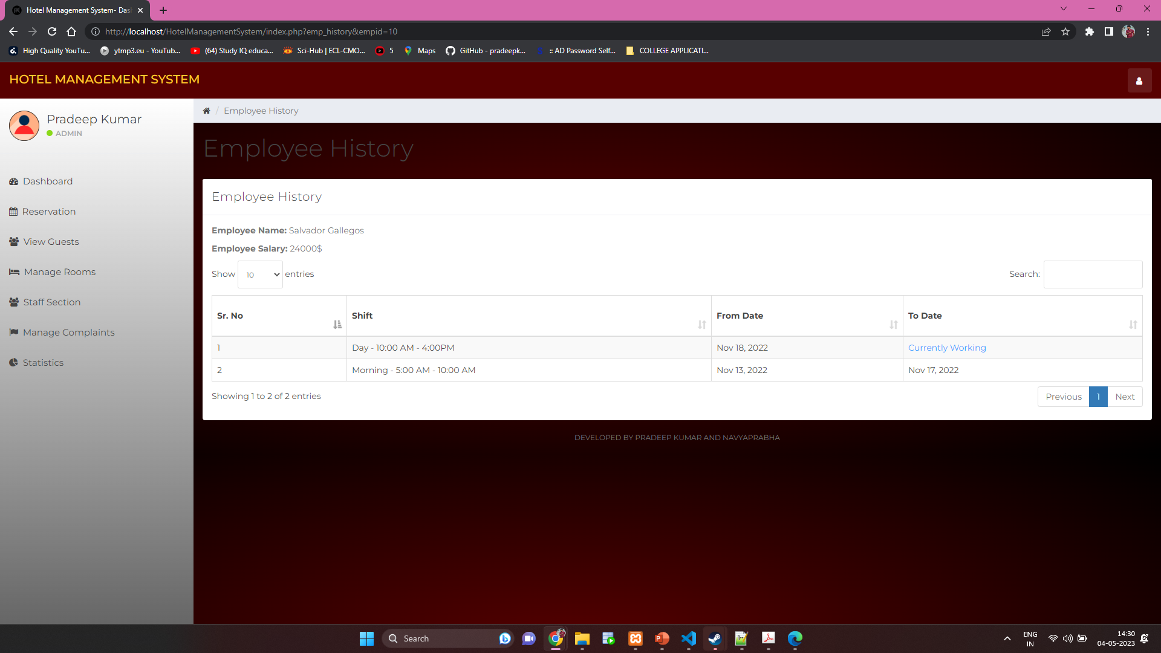

**Conclusion**

In conclusion, the hotel management system we have implemented includes features like user authentication, reservation management, guest management, room management, staff management, complaint management, statistics, search bar, and logout. It allows hotel staff to efficiently manage various operations like room reservations, customer details, room availability, complaints, employee details, and overall hotel expenses. The system also provides useful statistics to aid in decision-making processes. We have used XAMPP to set up a local hosting environment and PHP and javascript as the primary programming language to develop this system.

**Future Works**

There are several areas where the hotel management system can be improved and extended in the future. Some of the possible future works are:

**1. Integration with online Payment Gateway:** The system can be integrated with popular payment gateways to enable online payments and automate billing processes.

**2. Mobile App:** Developing a mobile app for the hotel management system will enable staff to access the system from anywhere and anytime.

3. **Feedback System:** A feedback system can be added to the system to allow guests to leave feedback on their experience, which can be used to improve the hotel's services.

5. **Social Media Integration:** Integrating the hotel management system with social media platforms can help in marketing the hotel and attracting more customers.

6. **Loyalty Program:** Implementing a loyalty program can help in retaining customers and improving customer satisfaction.

7. **Multiple Language Support:** Adding support for multiple languages can make the system accessible to a wider audience.

Overall, these future works can enhance the functionality of the hotel management system and make it more efficient and user-friendly.

**Appendix:**

[**https://draw.io/**](https://draw.io/)

[**https://fontawesome.com**](https://fontawesome.com/v5/cheatsheet/free/regular)

[**https://www.apachefriends.org/download.html**](https://www.apachefriends.org/download.html)

[**https://www.w3schools.com/css/**](https://www.w3schools.com/css/)

[**https://www.w3schools.com/php/**](https://www.w3schools.com/php/)

[**https://www.youtube.com/watch?v=zZ6vybT1HQs**](https://www.youtube.com/watch?v=zZ6vybT1HQs)

[**https://www.w3schools.com/sql/**](https://www.w3schools.com/sql/)

[**https://www.geeksforgeeks.org/sql-concepts-and-queries/**](https://www.geeksforgeeks.org/sql-concepts-and-queries/)

[**https://www.geeksforgeeks.org/javascript/**](https://www.geeksforgeeks.org/javascript/)

[**https://www.w3schools.com/html/**](https://www.w3schools.com/html/)